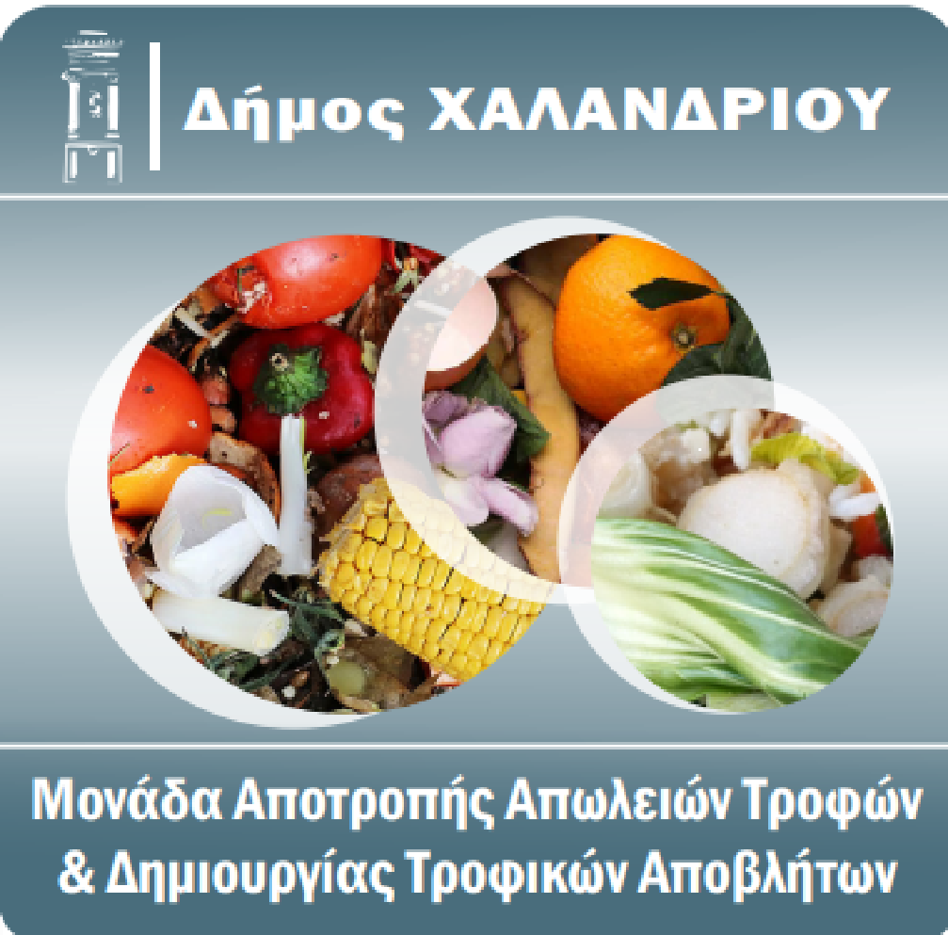

Educational Actions on Food Waste Prevention during the Summer 2025 Sports Camp at "Nikos Perkizas" Municipal Sports Center

Chalandri, September 2025

Contents
Contents 2
1. Introduction 3
2. Description of Actions 4
2.1 First Action – Storytelling Activity 4
2.1.1 Context and Objectives 4
2.1.2 Implementation and Methodology 4
2.1.3 Children’s Reflections and Visual Impressions 7
2.2 Second Action – Waste Measurement and Observation 12
2.2.1 Context and Objectives 12
2.2.2 Waste Separation Process 13
2.2.3 Measurement Methodology 16
2.2.4 Results of the first week 20
2.2.5 Results of the second week 25
2.2.6 Consolidated Results 29
2.2.7 Comparative Analysis between Weeks 1 and 2 33
2.2.8 Discussion of Findings 37
2.3 Third Action – Creative Art Workshop 39
2.3.1 Context and Objectives 39
2.3.2 Implementation of the Activity 39
2.3.3 Presentation and Interpretation of Paintings 41
3. Conclusions 49

1. Introduction
The Municipality of Chalandri organizes every year during the summer period, specifically immediately after the end of the school year until the end of July, a Sports Camp for children of the residents, who have completed the 1st to 6th grades of primary school. It takes place in 3 periods of 2 weeks each, from Monday to Friday, and in each period up to 250 children may participate. After the completion of the first registration phase and the verification of the required supporting documents, and if there are still vacant places available, a new registration phase opens, where children who have already secured a place in one period can also register. Consequently, there is a significant number of children who participate in 2 periods.
The Sports Camp takes place in the indoor and outdoor facilities of the "Nikos Perkizas" Municipal Sports Center, and includes a variety of sports, such as football, basketball and swimming, as well as art classes.
The Sports Camp in 2025 took place in the following 3 periods:
• 1st Period 16/6-27/6
• 2nd Period 30/6-11/6
• 3rd Period 14/6-25/6
In each of the 3 periods, the Circular Economy Unit of the Municipality of Chalandri, under the supervision of NTUA Professor and appointed circular economy advisor, Dr. Gerasimos Lymberatos, organized actions focusing on the reduction of food waste as well as the importance of recycling.

2. Description of Actions

2.1 First Action – Storytelling Activity

2.1.1 Context and Objectives

As part of the 1st period of the Sports Camp of the Municipality of Chalandri, an educational action was implemented based on the fairy tale "The Dream" by Beatrice Saia-Magrizou and the Food Bank of Thessaly. This action aimed to cultivate in children the values of cooperation, solidarity and the food waste prevention through a creative and experiential process.

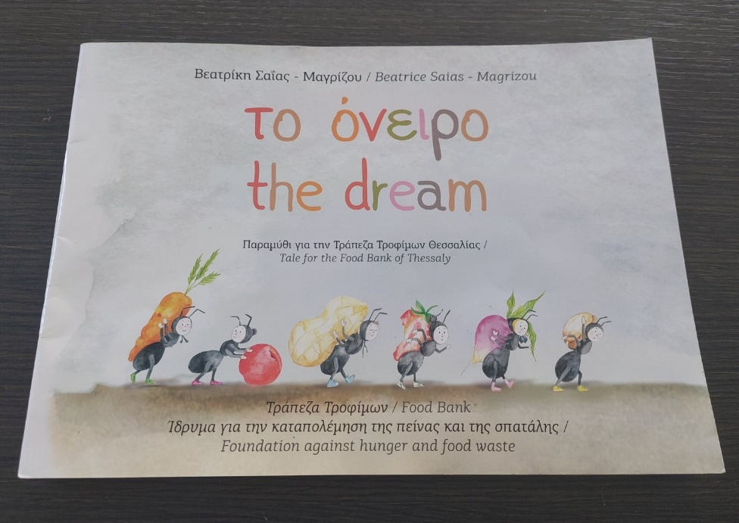
Image 1: The fairy tale "The Dream"

2.1.2 Implementation and Methodology
The fairy tale that was read to the children narrates the story of a little ant that sees in its dream that in an ant colony, some are collecting more food than they need, leaving other ants without. Soon there is chaos, until the ant realizes that the solution lies in cooperation, justice waste prevention. By conveying this important message to his companions, balance and joy are restored to the community.
On the first day, the book was handed over to the art teacher, Stamatis Zervas, who studied it and presented it to the participating children in a theatrical way, gaining their attention. In fact, several children began drawing inspired by the story before the teacher had even finished narrating. Afterwards, all the children were asked to create drawings with themes inspired by the fairy tale.
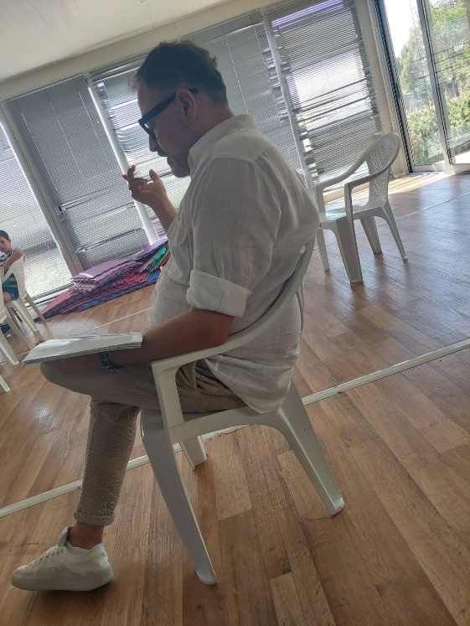
Image 2: The art teacher narrates the fairy tale to the children

A discussion followed, in which the children shared their impressions and comments. Among other things, they said:
"We shouldn't be wasteful"
"We must be cooperative"
"We must not be insatiable"
"We must help the weak"
"We don't need to collect things we don't need"
This activity helped children understand in an experiential and creative way the importance of cooperation, solidarity and proper food management.
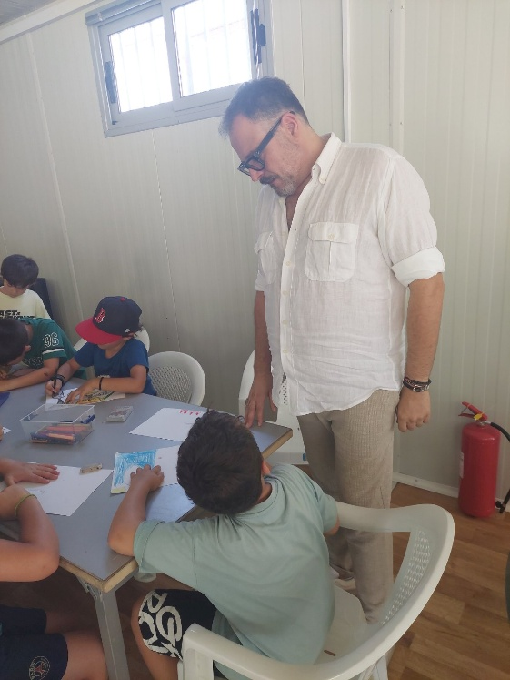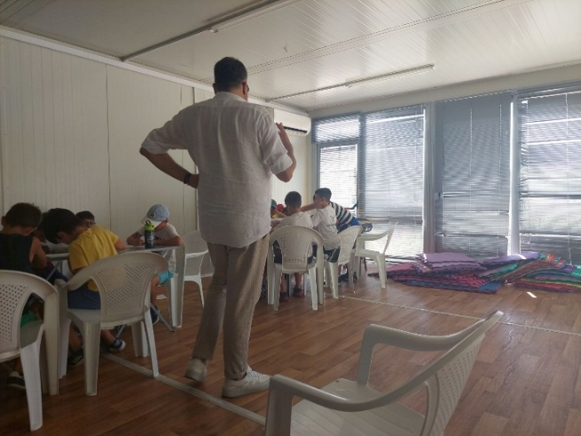
Image 3: The teacher with the children drawing Image 4: The teacher moving around the class

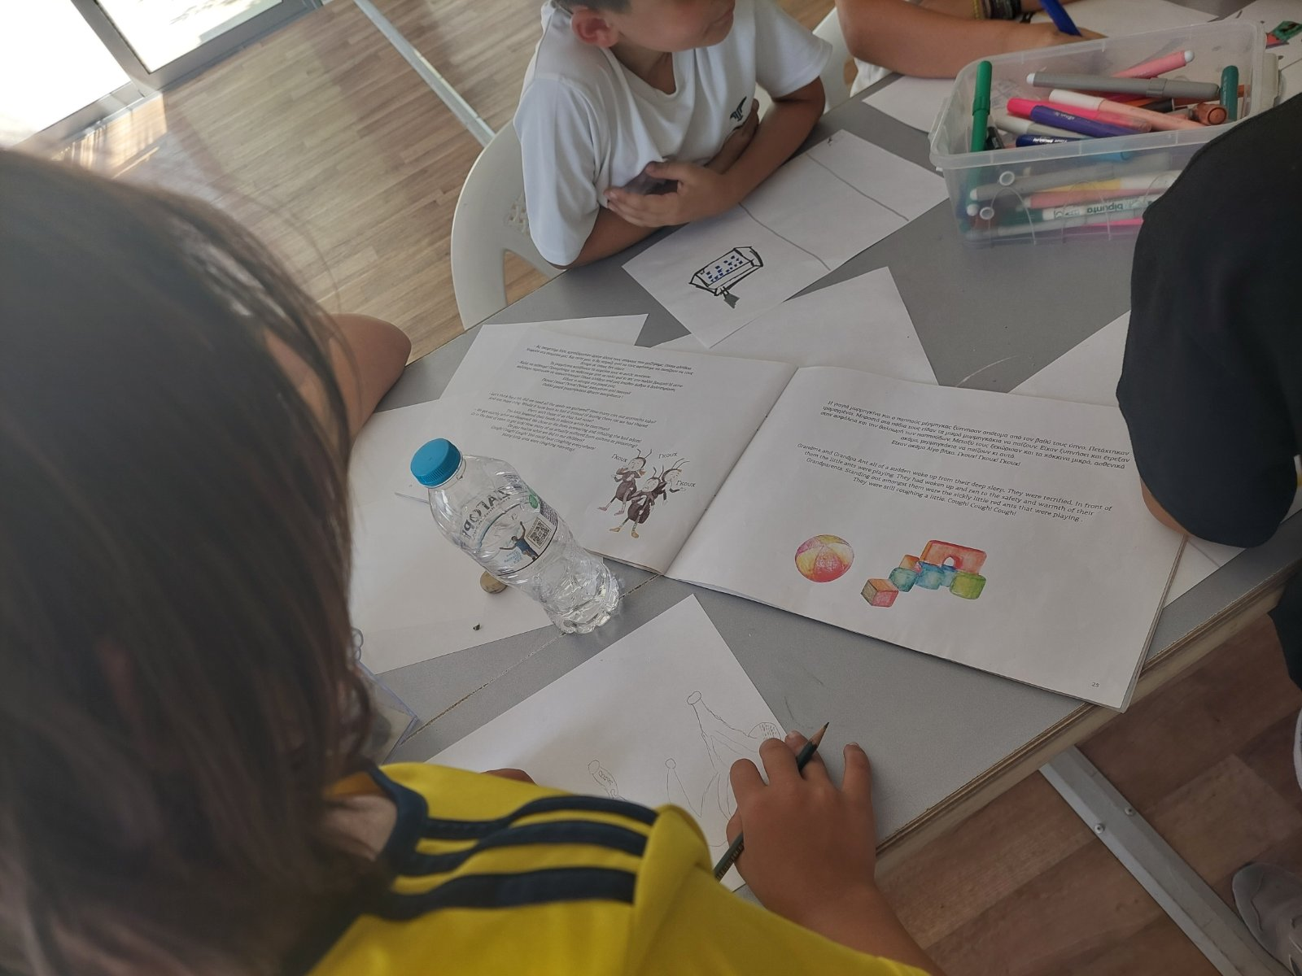
Image 5: Children drawing inspired by the story

2.1.3 Children’s Reflections and Visual Impressions

The drawings created by the children capture the messages of the fairy tale with imagination and creativity and form a beautiful set of works, part of which is presented below.

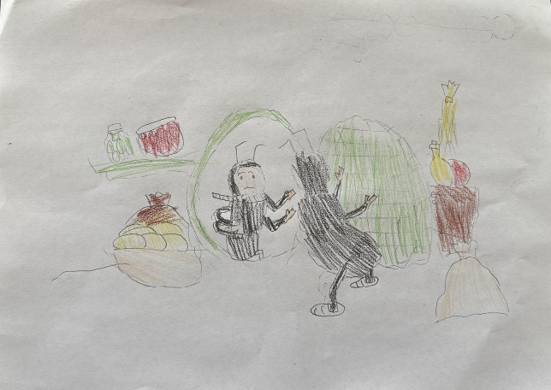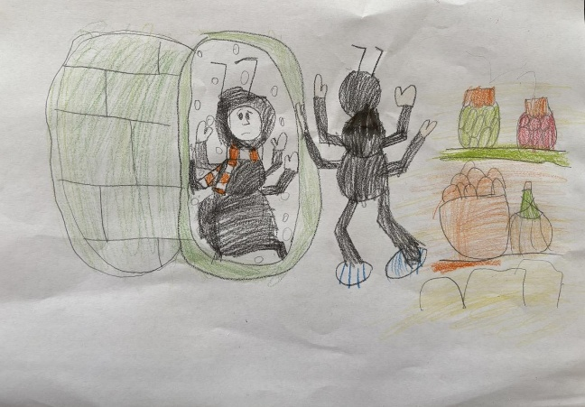

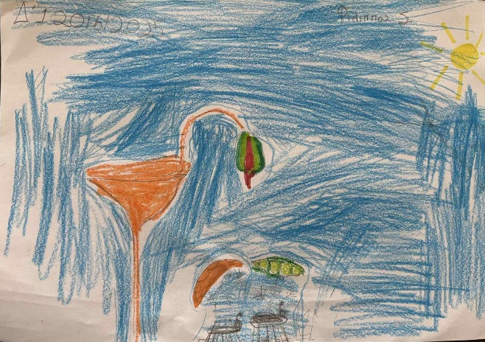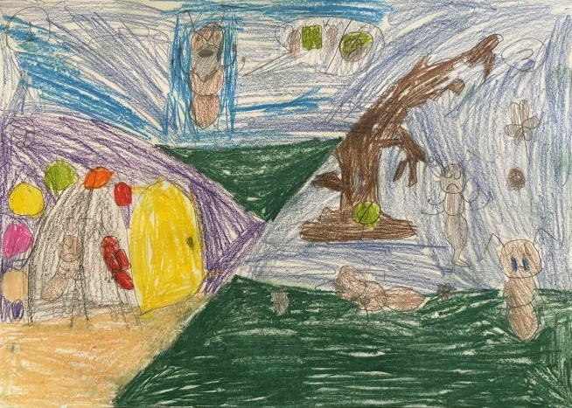

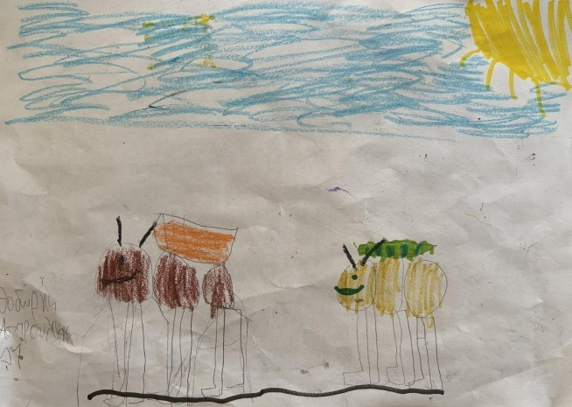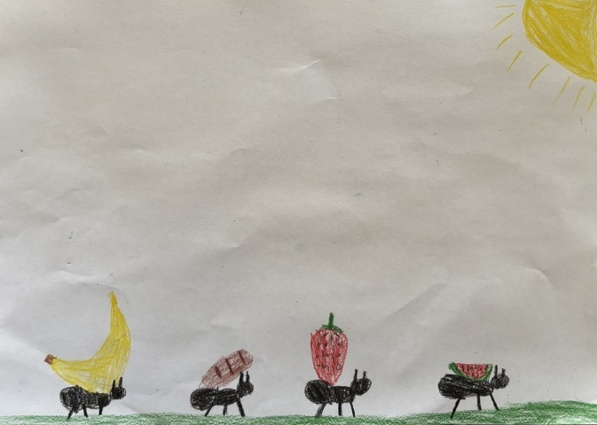

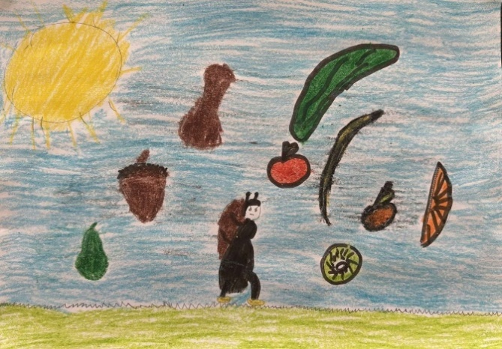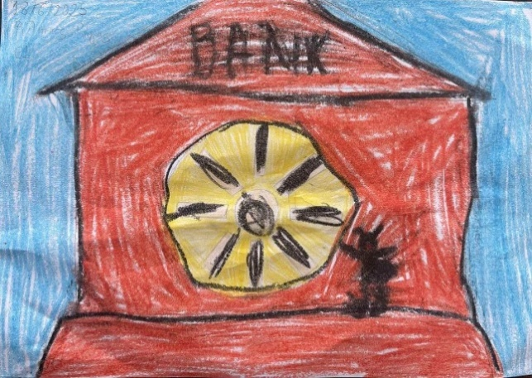

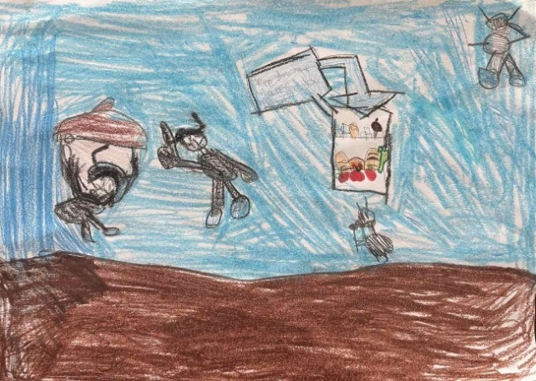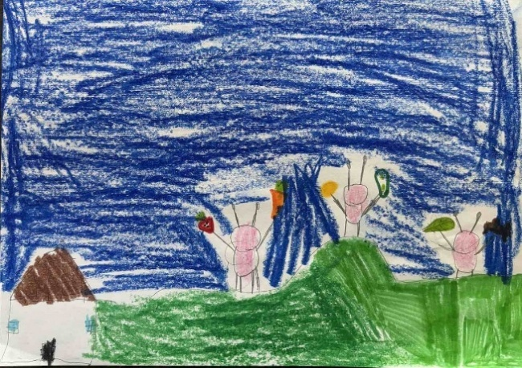

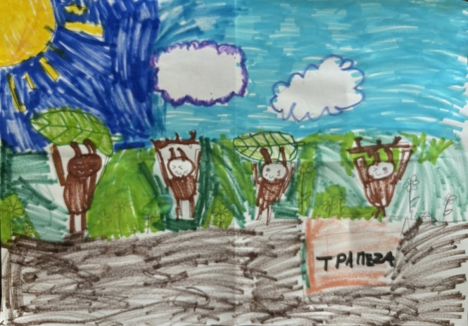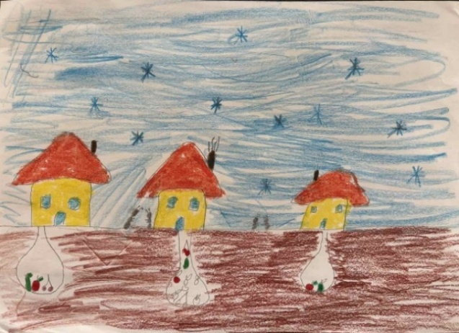

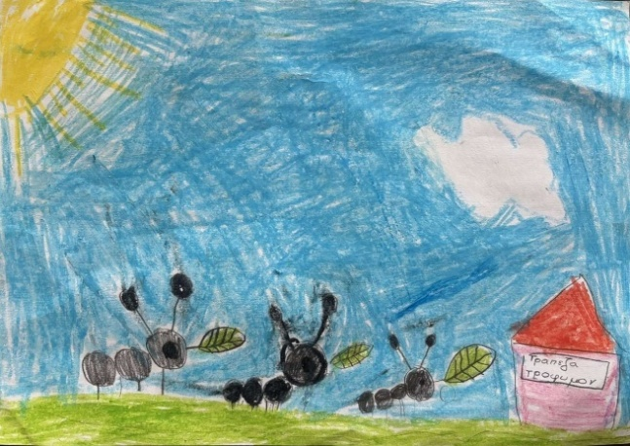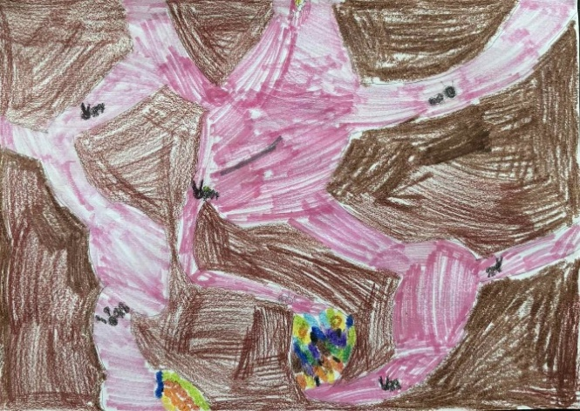
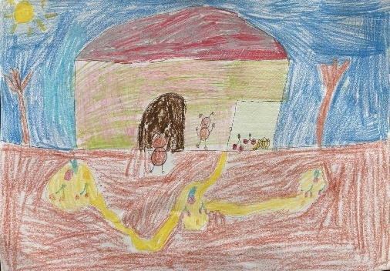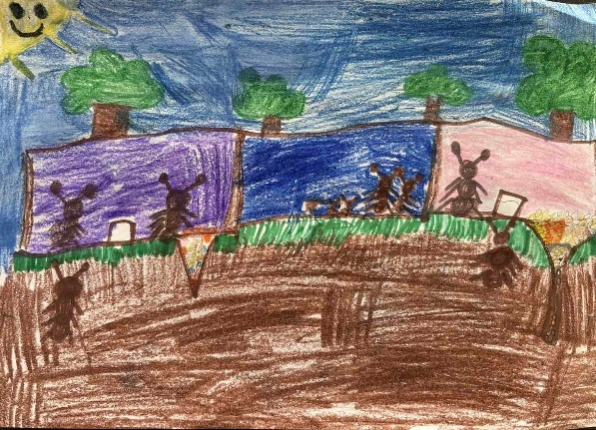

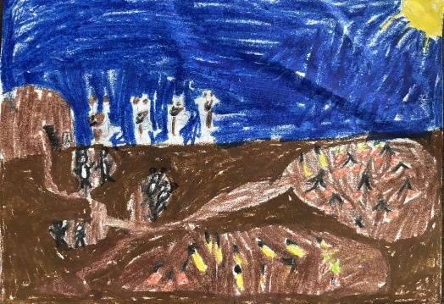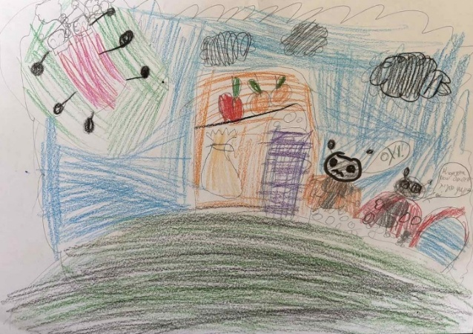

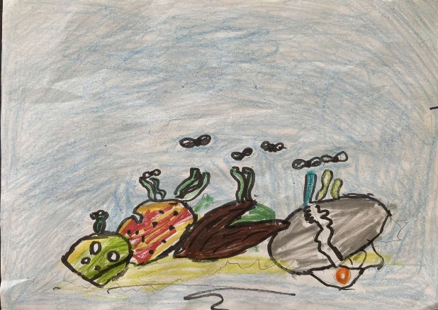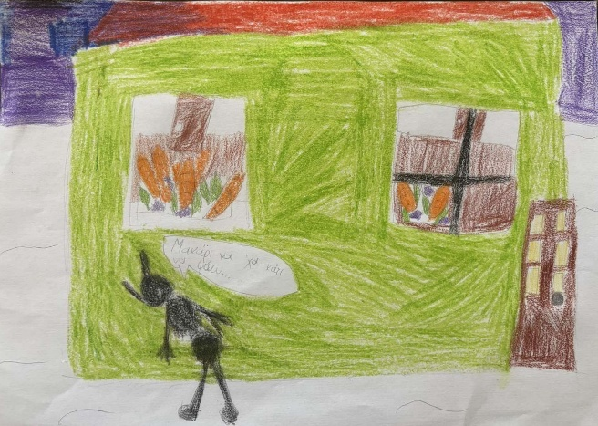

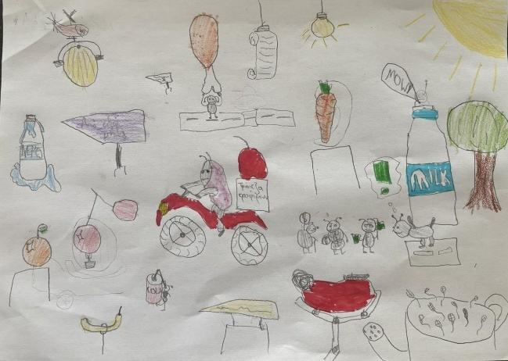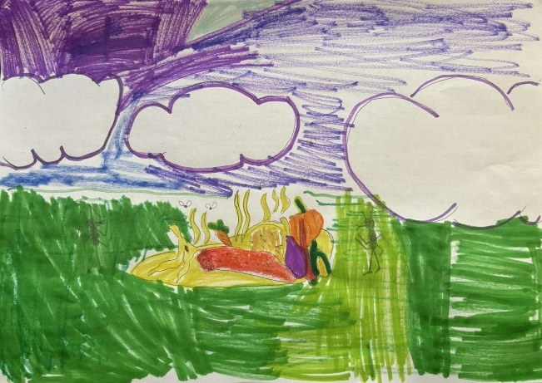
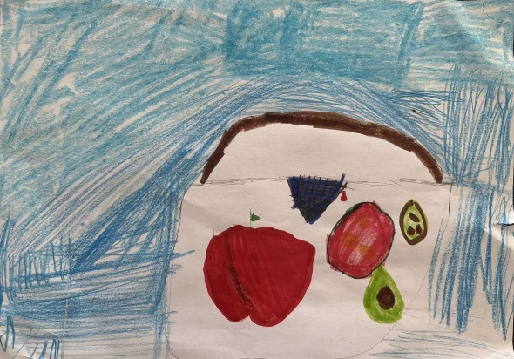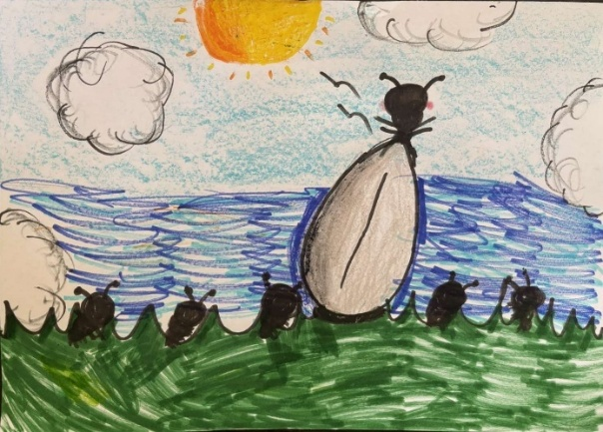

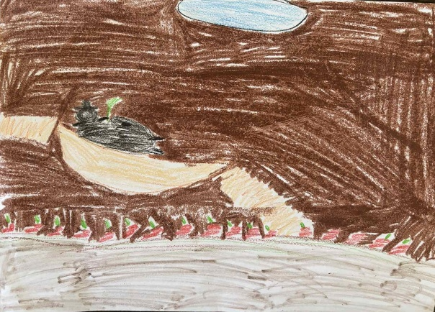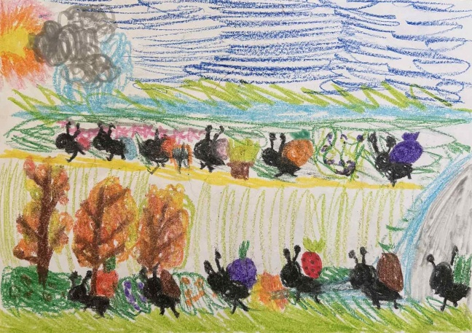

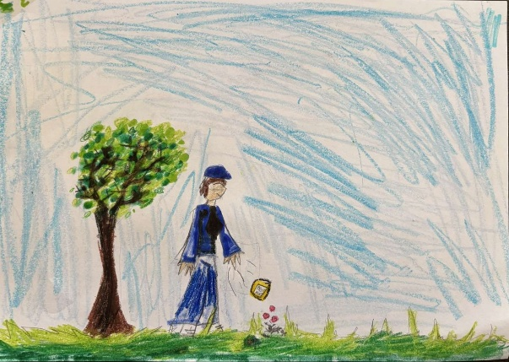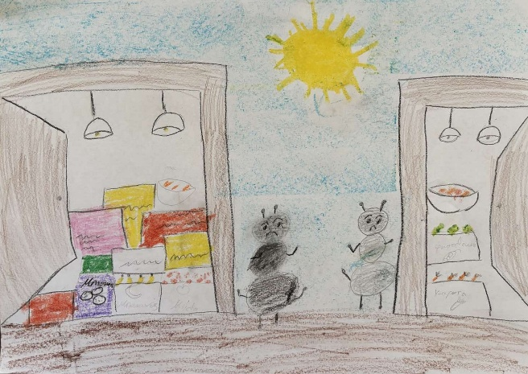

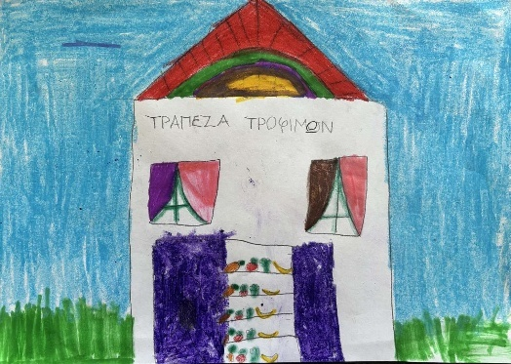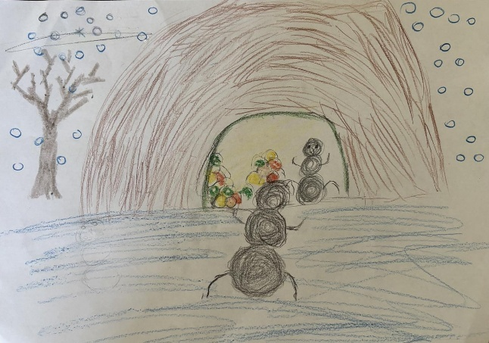

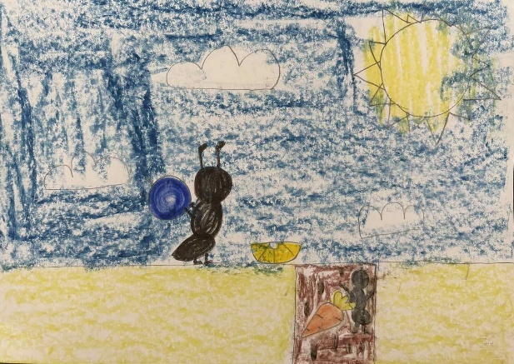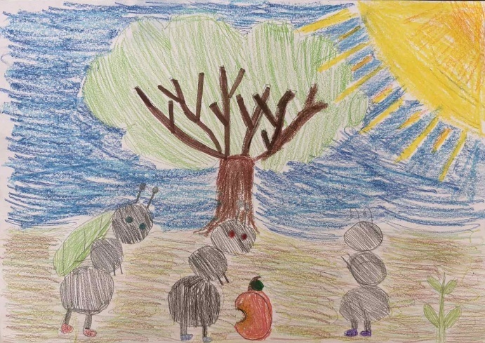

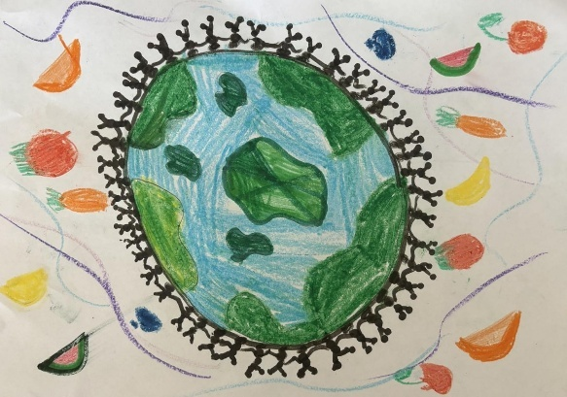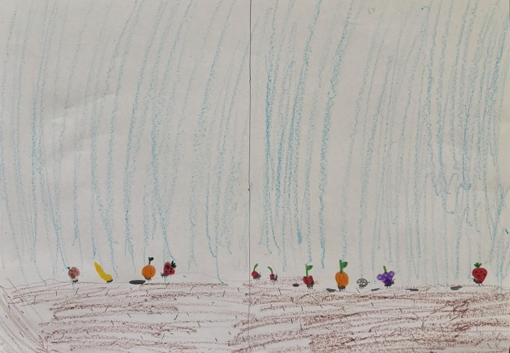

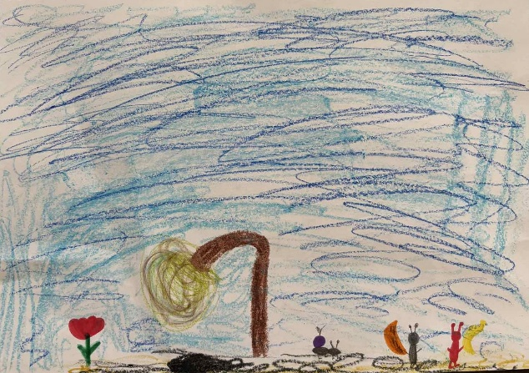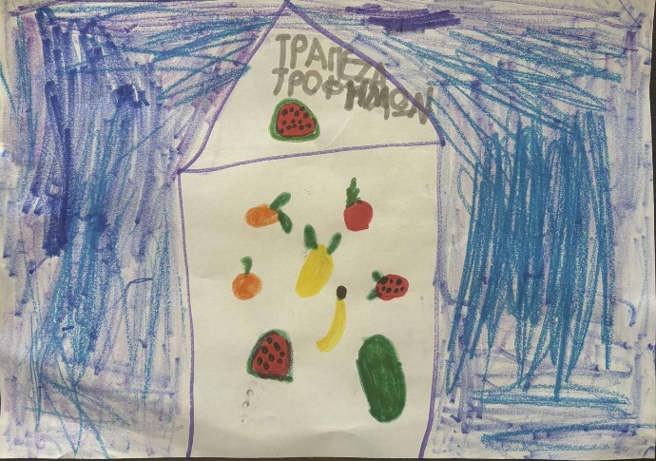

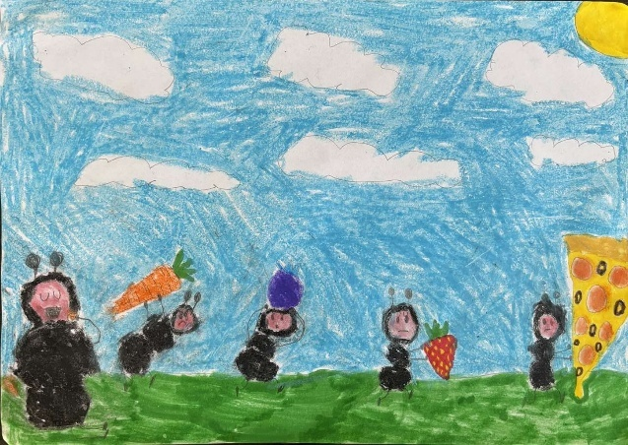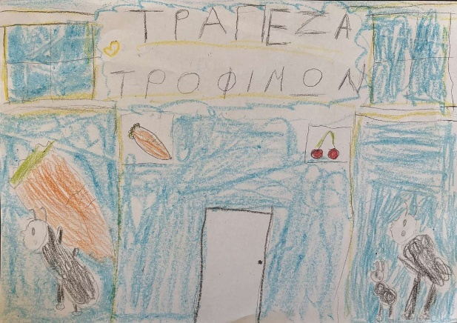

2.2 Second Action – Waste Measurement and Observation

2.2.1 Context and Objectives

The focus of the 2nd period's activity was to raise awareness among participating children about the importance of recycling, and specifically the recycling of inorganic and organic materials, which would otherwise end up in landfills with adverse environmental consequences such as the creation of microplastics that contaminate the soil or groundwater or the production of methane, the most significant greenhouse gas.
To implement the action, as will be described in detail below, the daily lunch process was utilized, in which all the children participated and which took place every day in the swimming pool hall. During the meal, waste was generated mainly from packaging and leftovers of baked goods, which the children were asked to separate in the correct way. In this context, the children were taught in a fun yet educational way to separate their waste into the Blue Bin (for recyclable materials, such as plastic and metal) and the Brown Bin (for organic waste).
At the same time, the action team carried out waste measurements, with the aim of drawing conclusions and observations regarding the quantity and type of waste produced. In this way, the action contributed on two levels, on the one hand it benefited the children as an experiential learning activity and on the other hand it served as a data collection tool for further study.
The rationale behind this action was the presence of an abundance of blue and brown bins on the streets of the Municipality of Chalandri, which should be used properly by its residents. The main goal was for the participating children to communicate this practice to their guardians and for them to adopt it as a family in their daily lives.

2.2.2 Waste Separation Process

For the implementation of the procedure, two Blue and two Brown bins were provided by the Waste and Recycling Directorate of the Municipality of Chalandri.
Additionally, the following were used for the measurements:
- Kitchen scale
- Buckets, which were used as weighing containers
- Tweezers
- Protective waterproof cover (tarpaulin)

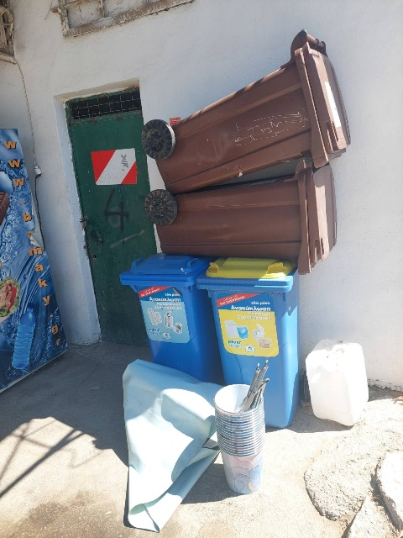
Image 6: Buckets and measuring tools

On the first day of the process, i.e. Monday 30/6/2025, two Brown bins and two Blue bins were placed in the area. During lunch, the children sat along the bleachers of the swimming pool, in front of which there is a corridor approximately 1,5 meters wide. The bins were organized in two pairs (one Blue and one Brown Bin) and placed near the opposite ends of the corridor, however, leaving free space for comfortable passage.
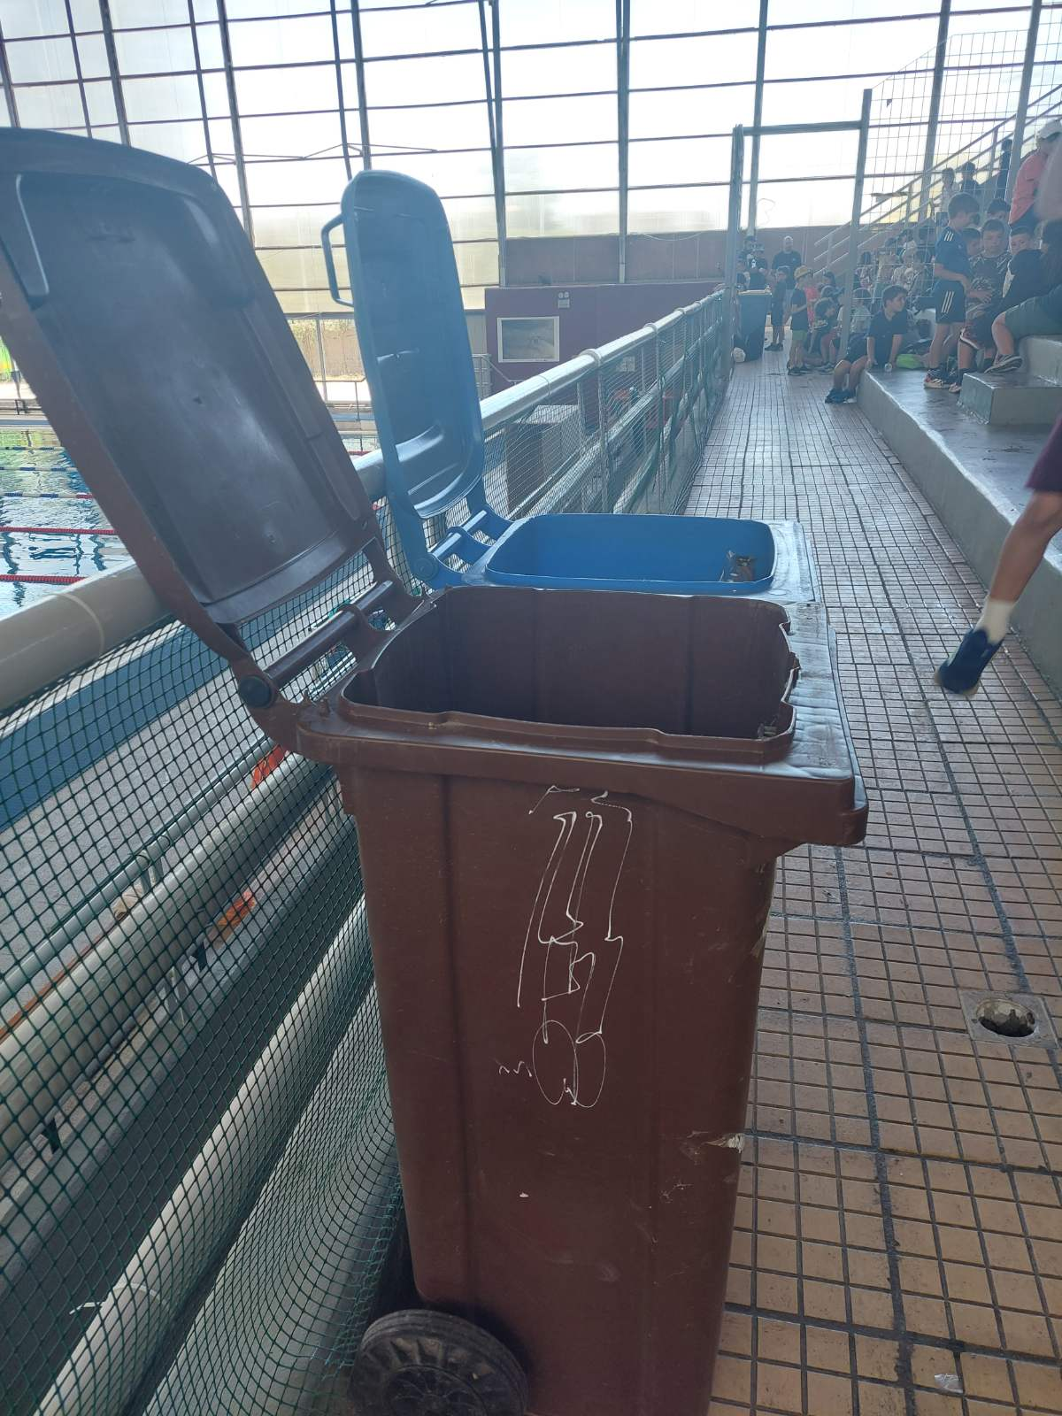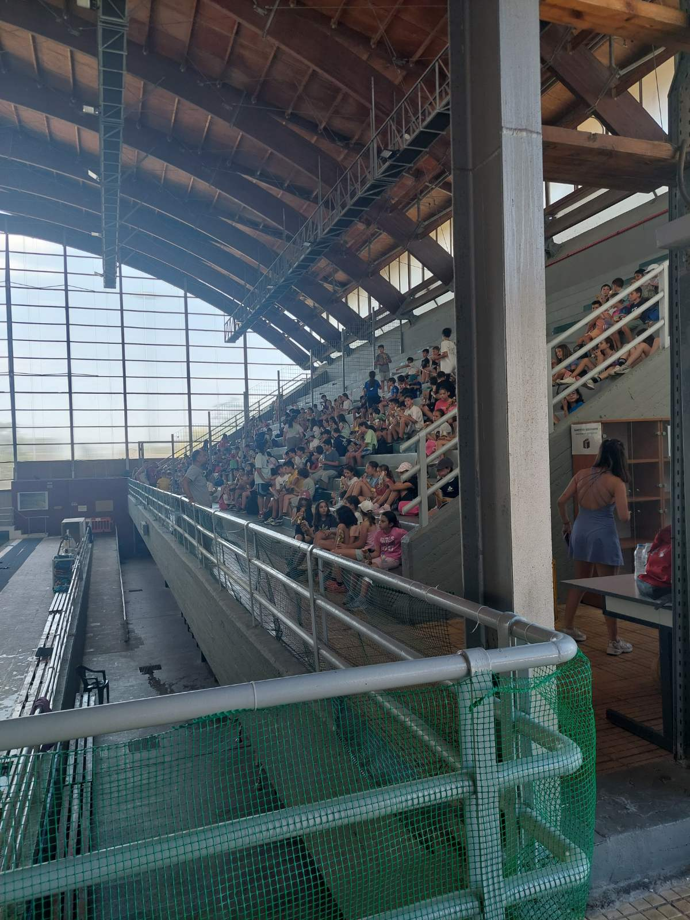
Image 7: Bins placed Image 8: Children sitting in the stands

Each child received a stuffed pastry in a sealed plastic bag, which was different every day. Specifically, it varied between a baguette, sandwich, Arabic pita, toast and croissant, all stuffed with cheese, cold meat and a small amount of mayonnaise. In addition, each child received a 500 ml plastic bottle of water.
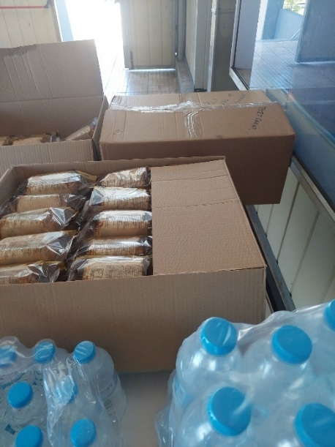
Image 9: Baked goods and water bottles offered
After the children had arrived, they were given a brief briefing about the bins that had been placed. They were informed that from the baked goods they had received, they should place the packaging in the blue bin and any leftovers of the baked goods in the Brown bin. The water bottles were also to be placed in the Blue bin. The children listened to the instructions quietly without asking any clarifying questions. From that day on and on a daily basis for the two weeks of the action, the process was repeated in the same way. After eating, the children had to discard the packaging in the Blue bin and the leftovers in the Brown bin. In practice, however, while several children followed the instructions, there were also cases where waste was thrown carelessly or in the wrong bin without paying special attention.
At the beginning of the second week (07/06/2025 – 11/06/2025) a brief report, with a positive sign, was given to the children regarding the results of the first week’s measurements, and they were encouraged to continue with the same interest in waste separation. Subsequently, a more detailed briefing was given regarding waste separation and the use of the blue and brown bins. Despite the reduced discipline compared to the first week, mainly due to fatigue, the children demonstrated interest and confirmed their understanding of the information provided.
It should be noted that the children were free to bring other food with them for consumption, since they were of course not obliged to eat exclusively the baked goods provided. These foods came either from the participants' homes or from the Sports Center cafeteria. However, all children received the baked goods and water upon entering the venue, regardless of their intention or desire to consume them. This resulted in a proportion of children discarding either all or almost all of the baked goods, while a smaller proportion took them outside the venue. The final destination of the baked goods in the latter case could not be monitored. However, according to testimonies from the cleaning staff, some of these children preferred to discard them in regular waste bins outside the venue and not to enter the separation process. This behavior is estimated to be due, among other factors, to a lack of willingness as well as to the fact that the presence of the coaches may have caused embarrassment or hesitation regarding their participation in the separation process.
Another important observation is that from the first day, the cleaning staff noticed that the stands had less waste and the image they presented was, although not satisfactory, better than the first period.
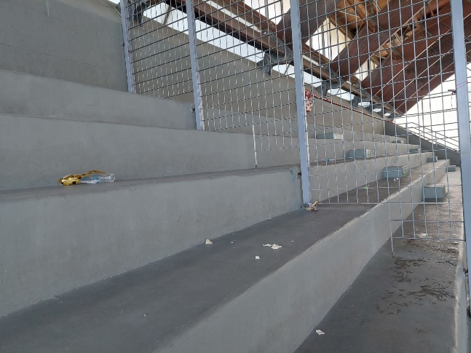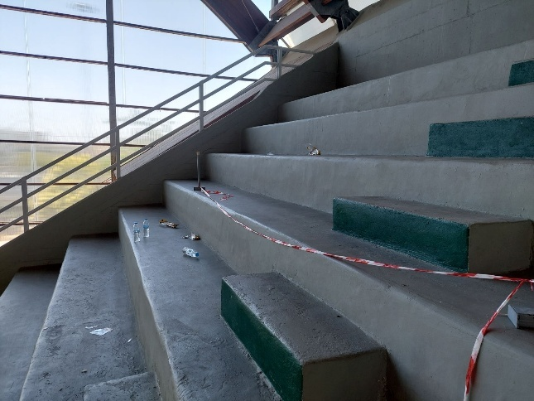
Image 10: Grandstands after the meal Image 11: Grandstands after the meal

2.2.3 Measurement Methodology

According to the initial planning, for each week, measurements would be taken on Wednesday and Friday after lunch. In the first week (30/06/2025 – 04/07/2025) measurements were taken on Wednesday 02/07/2025, for 3 days’ waste (30/06/2025, 01/07/2025 and 02/07/2025), and on Friday 04/07/2025 for 2 days’ waste (03/07/2025 and 04/07/2025).
However, in the second week, a field trip was organized for the children on Wednesday 09/07/2025 and Thursday 10/07/2025. Half of the children went on the field trip on the first day while the remaining half went on the second day. The participants on the field trip received and consumed the bakery product outside the sports facilities and thus no information could be collected for those days. Consequently, in that week a measurement was taken on Wednesday 09/07/2025, however before the children's lunch, covering the waste of 2 days (07/07/2025 and 08/07/2025). The second measurement was taken on Friday 11/07/2025, covering the waste of three days (09/07/2025, 10/07/2025 and 11/07/2025). This adjustment was made on the assumption that the waste generated on 09/07/2025 and 10/07/2025 was qualitatively and quantitatively approximately equivalent to that of a single day.
On each of the scheduled measurement days, the four bins, namely the two Blue and the two Brown, were gathered in an indoor area, protected from the weather and at a distance from the athletes present, so as not to cause any nuisance, mainly in terms of odor of the waste.
Due to the large volume of the bins and the limited space available, the procedure was applied to each bin individually and sequentially. The contents of each bin were unloaded onto a tarpaulin to prevent liquid leakage onto the floor. Initially, the water bottles were collected and counted. It should be noted that the bottles were not weighed, since each bottle contained a different amount of water and the determination of this amount was not relevant to the objectives of the procedure.
Subsequently, the contents of the bin were separated into the following categories:
- Packaging of distributed baked goods
- Other packaging
- Leftovers from distributed baked goods
- Other food waste residues
- Other waste
Each waste category was temporarily placed in one or more weighing containers in order to record their weight. For hygiene reasons, where deemed necessary, forceps were used to avoid direct contact with the waste. For the same reason, disposable plastic gloves were used throughout the process.
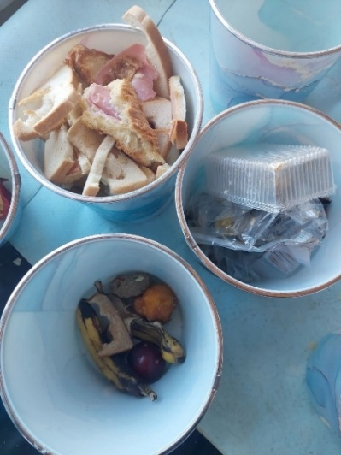
Image 12: Separated waste categories in weighing containers

Initially, on the first day of measurement, the empty weighing containers were weighed to determine their tare weight. Then, each of the full containers was weighed on the scale (gross weight) and by subtracting the tare weight, the net weight of the contents was calculated. The weighing results for each container were systematically recorded. In cases where a waste category was distributed to more than one container, the net weights were added together to obtain the total weight per category. In this way, overall results were obtained for both the Brown bin and the Blue bin.

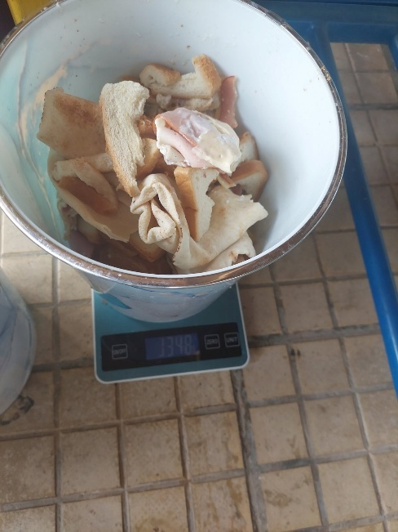
Image 13: Sample of leftover baked goods placed on the scale for daily weight measurement

Then, the process was repeated daily in a consistent manner. Each day, the same bakery product was distributed to all children, a specific product for each day, and only one type of packaging was used for all items on that day. Overall, during the period, two different types of packaging were used, a plastic-wrapped tray and a simple plastic bag-type package. However, they were never used simultaneously on the same day. Because the gross weight of the bakery product showed small fluctuations from day to day, it was weighed daily to obtain the daily average gross weight per piece. At the same time, the type of packaging used on each day was also weighed in order to determine the package weight per piece. The number of distributed pastries was also recorded.
We set the following assumptions to make the interpretation of the data clear:
- Those who discarded leftover baked goods in the bins under consideration also discarded their packaging.
- Conversely, those who discarded packaging in the same bins also discarded any leftover baked goods there.
- The packages are discarded intact (without significant loss of part/weight).
- The baked goods for which no packaging was found in the specific bins were either discarded in other bins (inside/outside the stadium) or consumed later and are therefore not included in this sample.
Based on the above assumptions, one package corresponds to one bakery product participating in the sample. Therefore, by weighing the packages collected in the bins under consideration and knowing the package weight per piece for each day, we were able to determine the number of bakery products taken into account in the calculations, by dividing the total package weight by the corresponding daily package weight per piece.
This ensures that the calculations and conclusions made are based only on the bakery products whose disposal is documented by the packages actually found in the stream under consideration.
Based on these data, the average net weight per piece (daily gross weight minus packaging weight) was determined for each day, as well as the daily totals, i.e. the net total (average net weight multiplied by number of pieces) and the total packages (packaging weight per piece multiplied by number of pieces).
Finally, the daily results were summed per week, to obtain the total net weight of the distributed baked goods and the total weight of the packages for each week.
As described above, the weighing process was carried out twice a week. The results of these two measurements were combined and considered as a single set for each week, as no information action or other intervention that could influence the behavior of the participating children took place in the meantime. The results of each of the two weeks of the action, as well as the overall results, are presented and analyzed in the next chapter. It should be noted, however, that the packaging and organic waste examined related exclusively to the baked goods offered and, for the sake of brevity, will be called “packaging” and “organic waste”, despite the fact that they did not constitute the entire contents of the bin.
After the completion of the process, the waste from each category was placed back in the appropriate bins, i.e. all packaging, regardless of origin, was placed in the two Blue Bins and all organic waste in the 2 Brown Bins. Then, the contents of the four bins were emptied into the corresponding large bins located in the Sports Center area. The remaining waste was placed in the Green Bin of the area. The weighing containers, the tongs and the tarpaulin were washed and stored in a predetermined area to be ready for use in the next measurement.

2.2.4 Results of the first week

- Packaging Waste Distribution

This subsection presents the distribution of packaging waste by weight in the Blue and Brown bins in the first week. The table below (Table 1) presents the absolute quantities [g] and the corresponding weight percentages [%] of the total packaging waste. These values are used in the following subsection (Recovery, Purity and Efficiency Indicators).

Table 1: Distribution of packaging waste weight per bin in the first week
 | Blue bins | Brown bins | TOTAL
Weight of packaging waste [g] | 3,900 | 530 | 4,430
Share of packaging waste per bin [%] | 88.04% | 11.96% | 100.00%

Chart 1: Share of packaging waste weight per bin in the first week

As illustrated in Chart 1, most of the packaging waste (88.04%) was disposed in the Blue bins whereas a smaller share (11.96%) ended up in the Brown bins.

- Organic waste Distribution

This subsection presents the distribution of the weight of organic waste in the Blue and Brown bins in the first week. The table below (Table 2) includes the absolute quantities [g] as well as the corresponding percentages [%] of the total organic waste. These values are used in the following subsection (Recovery, Purity and Efficiency Indicators).

Table 2: Distribution of organic waste weight per bin in the first week
 | Blue bins | Brown bins | TOTAL
Weight of organic waste [g] | 3,708 | 20,410 | 24,118
Share of organic waste per bin [%] | 15.38% | 84.62% | 100.00%

Chart 2: Share of organic waste weight per bin in the first week

As illustrated in Chart 2, most of the organic waste (84.62%) was disposed of in the Brown bins, whereas only a smaller share (15.38%) ended up in the Blue bins.

- Waste Distribution by Bin Type (Blue vs. Brown)

This chapter examines the composition of the contents of each bin, i.e. separately the Blue and Brown Bins, during the first week. Table 3 presents the total weight per bin [g] as well as the absolute quantities [g] of packaging and organic waste found in the Blue and Brown Bins. These figures are used to calculate the indicators in the next subchapter (Recovery, Purity and Efficiency Indicators).

Table 3: Distribution of packaging and organic waste weight per bin in the first week
 | Blue bins | Brown bins
Total weight per bin [g] | 7,608 | 20,940
Weight of packaging waste [g] | 3,900 | 530
Weight of organic waste [g] | 3,708 | 20,410

Chart 3: Share of packaging and organic waste weight per bin in the first week

As shown in Chart 3, during the first week the Blue bin’s content was almost evenly distributed between packaging (3,900 g) and organic waste (3,708 g). In contrast, the Brown bin was dominated by organic waste (20,410 g), with packaging accounting for only 530 g. Consequently, the total weight of the Brown bin (20,940 g) was substantially higher than that of the Blue bin (7,608 g).

- Recovery, Purity and Efficiency Indicators
In this subchapter, the waste separation performance of participants in the two collection streams, namely packaging in Blue Bins and Organics in Brown Bins, is evaluated through three indicators, Recovery, Purity and Efficiency, based on the weight values of packaging and organic waste per bin as presented in subchapters A and B and summarized in subchapter C. Therefore, the distribution tables are not repeated but only the calculated values of the indicators are presented.
In the context of this process, Recovery expresses the percentage of waste directed to the appropriate bin, in relation to the total waste generated in the corresponding stream (packaging or organics). Purity reflects the percentage of material in the bin that actually belongs to the specific stream, in relation to the total weight of waste collected in this bin. Finally, Efficiency is a combined indicator that reflects in a single value both Recovery, i.e. the percentage of waste directed to the correct bin, and Purity, i.e. the percentage of the contents of each bin that actually belongs to the corresponding stream.

Based on the above definitions, the indicators are calculated as follows:

Recovery per stream

${Recovery}_{pack}=R_{pack}=\frac{{Weight}_{pack,Blue}}{{Weight}_{pack,Blue}+{Weight}_{pack,Brown}}=\frac{3.900 g}{3900g+530 g}=88,04\%$

${Recovery}_{org}=R_{org}=\frac{{Weight}_{org,Brown}}{{Weight}_{org,Blue}+{Weight}_{org,Brown}}=\frac{20.410 g}{3.708 g+20.410 g}=84,62\%$

Purity per bin type

${Purity}_{Blue}=P_{Blue}=\frac{{Weight}_{pack,Blue}}{{Weight}_{tot,Blue}}= \frac{3.900 g}{3.900 g+3.708 g}=51,26\%$

${Purity}_{Brown}=P_{Brown}=\frac{{Weight}_{org,Brown}}{{Weight}_{tot,Brown}}= \frac{20.410 g}{530 g+20.410 g}=97,47\%$

Separation Efficiency

$${Efficiency}_{\left(pack,org\right)}=Ε_{\left(pack,org\right)}=$$
$\left|\frac{{Weight}_{pack,Blue}}{{Weight}_{pack,Blue}+{Weight}_{pack,Brown}}-\frac{{Weight}_{org,Blue}}{{Weight}_{org,Blue}+{Weight}_{org,Brown}}\right|$=

$$\left|\frac{3.900 g}{3.900 g+530g}-\frac{3.708 g}{3.708 g+20.410 g}\right|=72,66\%$$

2.2.5 Results of the second week

- Packaging Waste Distribution

Similarly to the first week, this subsection presents the distribution of the weight of discarded packaging between the Blue and Brown bins for the 2nd week. Table 4 presents the absolute quantities [g] as well as the corresponding percentages by weight of the total [%].

Table 4: Distribution of packaging waste weight per bin in the second week
 | Blue bins | Brown bins | TOTAL
Weight of packaging waste [g] | 2,414 | 348 | 2,762
Share of packaging waste per bin [%] | 87.40% | 12.60% | 100.00%

Chart 4: Share of packaging waste weight per bin in the second week

As can be seen in Chart 4, the disposal of packaging was mainly done in the Blue bin (87.40%) with the remaining 12.60% being disposed of in the Brown bin.

- Organic waste Distribution

Similarly to the previous section, this subsection presents the distribution of the weight of organic waste between the Blue and Brown bins for week 2. Table 5 shows the absolute quantities [g] as well as the corresponding percentages of the total [%].

Table 5: Distribution of organic waste weight per bin in the second week
 | Blue bins | Brown bins | TOTAL
Weight of organic waste [g] | 2,283 | 21,412 | 23,695
Share of organic waste per bin [%] | 9.63% | 90.37% | 100.00%

Chart 5: Share of organic waste weight per bin in the second week

As shown in Chart 5, 90.37% of organic waste ended up in the Brown Bin, while 9.63% was disposed of in the Blue Bin.
- Waste Distribution by Bin Type (Blue vs. Brown)

Similarly to the first week, this subsection presents the composition of the contents of each bin for the second week. Table 6 lists the total weight per bin [g] as well as the absolute quantities [g] of packaging and organic waste found in the Blue and Brown Bins.

Table 6: Distribution of packaging and organic waste weight per bin in the second week
 | Blue bins | Brown bins
Total weight per bin [g] | 4,697 | 21,760
Weight of packaging waste [g] | 2,414 | 348
Weight of organic waste [g] | 2,283 | 21,412

Chart 6: Share of packaging and organic waste weight per bin in the second week

As can be seen from Chart 6, in the second week the Blue Bin shows an almost equal distribution by weight between packaging (2,414 g) and organic waste (2,283 g). In contrast, in the Brown Bin organic waste (21,412 g) strongly dominates over packaging (348 g), resulting in the total weight of the Brown Bin (21,760 g) being significantly higher than that of the Blue Bin (4,697 g).

- Recovery, Purity and Efficiency Indicators

Similarly to the first week, this sub-chapter presents the values of the Recovery, Purity, and Efficiency indicators for the second week. The indicators were calculated from the packaging and organic waste weights per bin, as reported in the relevant sub-chapters for the second week.

Recovery per stream

${Recovery}_{pack}=R_{pack}=\frac{{Weight}_{pack,Blue}}{{Weight}_{pack,Blue}+{Weight}_{pack,Brown}}=\frac{2.414 g}{2.414g+348 g}=87,40\%$

${Recovery}_{org}=R_{org}=\frac{{Weight}_{org,Brown}}{{Weight}_{org,Blue}+{Weight}_{org,Brown}}=\frac{21.412 g}{2.283 g+21.412 g}=90,37\%$

Purity per bin

${Purity}_{Blue}=P_{Blue}=\frac{{Weight}_{pack,Blue}}{{Weight}_{tot,Blue}}= \frac{2.414 g}{2.414 g+2.283 g}=51,39\%$

${Purity}_{Brown}=P_{Brown}=\frac{{Weight}_{org,Brown}}{{Weight}_{tot,Brown}}= \frac{21.412 g}{348 g+21.412 g}=98,40\%$

Separation Efficiency

$${Efficiency}_{\left(pack,org\right)}=Ε_{\left(pack,org\right)}=$$
$\left|\frac{{Weight}_{pack,Blue}}{{Weight}_{pack,Blue}+{Weight}_{pack,Brown}}-\frac{{Weight}_{org,Blue}}{{Weight}_{org,Blue}+{Weight}_{org,Brown}}\right|$=

$$\left|\frac{2.414 g}{2.414 g+348g}-\frac{2.283 g}{2.283 g+21.412 g}\right|=77,77\%$$

2.2.6 Consolidated Results

- Packaging Waste Distribution

This subsection presents the weight distribution of packaging waste between the Blue and Brown bins for the entire period (sum of the first and second weeks). Table 7 reports the absolute quantities [g] and the corresponding weight percentages [%] of the total.

Table 7: Distribution of packaging waste weight per bin in total
 | Blue bins | Brown bins | TOTAL
Weight of packaging waste [g] | 6,314 | 878 | 7,192
Share of packaging waste per bin [%] | 87.79% | 12.21% | 100.00%

Chart 7: Share of packaging waste weight per bin in total

As shown in Chart 7, most packaging waste was disposed of in the Blue bins (87.79%), while the remaining 12.21% ended up in the Brown bins.

- Organic waste Distribution

This subsection presents the weight distribution of organic waste between the Blue and Brown bins for the entire period. Table 8 reports the absolute quantities [g] and the corresponding weight percentages [%] of the total.

Table 8: Distribution of organic waste weight per bin in total
 | Blue bins | Brown bins | TOTAL
Weight of organic waste [g] | 5,991 | 41,822 | 47,813
Share of organic waste per bin [%] | 12.53% | 87.47% | 100.00%

Chart 8: Share of organic waste weight per bin in total

As shown in Chart 8, organic waste was mainly found in the Brown bins (87.47%), while the Blue bins corresponded to 12.53%.
- Waste Distribution by Bin Type (Blue vs. Brown)

This subsection examines the composition of each bin for the entire period. Table 9 presents the total weight per bin [g] and the absolute quantities [g] of packaging and organic waste found in the Blue and Brown bins.

Table 9: Distribution of packaging and organic waste weight per bin in total
 | Blue bins | Brown bins
Total weight per bin [g] | 12,305 | 42,700
Weight of packaging waste [g] | 6,314 | 878
Weight of organic waste [g] | 5,991 | 41,822

Chart 9: Share of packaging and organic waste weight per bin in total

As shown in Chart 9, in the Blue bins the contents were almost balanced between packaging (6,314 g) and organic waste (5,991 g). In contrast, the Brown bins were dominated by organic waste (41,822 g) with comparatively little packaging (878 g), resulting in a substantially higher total weight for the Brown bins.

- Recovery, Purity and Efficiency Indicators

This subchapter presents the values of the Recovery, Purity, and Separation Efficiency indicators for the entire period. The indicators were calculated from the packaging and organic waste weights per bin, as reported in the relevant subchapters.

Recovery per stream

${Recovery}_{pack}=R_{pack}=\frac{{Weight}_{pack,Blue}}{{Weight}_{pack,Blue}+{Weight}_{pack,Brown}}=\frac{6.314 g}{6.314 g+878 g}=87,79\%$

${Recovery}_{org}=R_{org}=\frac{{Weight}_{org,Brown}}{{Weight}_{org,Blue}+{Weight}_{org,Brown}}=\frac{41.822 g}{5.991 g+41.822 g}=87,47\%$

Purity per bin

${Purity}_{Blue}=P_{Blue}=\frac{{Weight}_{pack,Blue}}{{Weight}_{tot,Blue}}= \frac{6.314 g}{6.314 g+5.991 g}=51,31\%$

${Purity}_{Brown}=P_{Brown}=\frac{{Weight}_{org,Brown}}{{Weight}_{tot,Brown}}= \frac{41.822 g}{878 g+41.822 g}=97,94\%$

Separation Efficiency

$${Efficiency}_{\left(pack,org\right)}=Ε_{\left(pack,org\right)}=$$
$\left|\frac{{Weight}_{pack,Blue}}{{Weight}_{pack,Blue}+{Weight}_{pack,Brown}}-\frac{{Weight}_{org,Blue}}{{Weight}_{org,Blue}+{Weight}_{org,Brown}}\right|$=

$$\left|\frac{6.314 g}{6.314 g+878g}-\frac{5.991 g}{5.991 g+41.822 g}\right|=72,56\%$$

2.2.7 Comparative Analysis between Weeks 1 and 2

This chapter evaluates changes in participants' behavior regarding waste separation between the first and second weeks. Note that at the beginning of the second week, more detailed and extensive information was provided to the children and the aim is to evaluate the possible impact of this information on the results.
The sample size is not the same between the two measurement weeks, due to the different number of children and the different number of baked goods consumed in the area. Therefore, comparisons are made exclusively as weight percentages of the total.

- Packaging Waste Distribution (change per bin)

This subsection evaluates the change in the distribution of packaging waste between the Blue and Brown bins from the first to the second week.

Table 10: Change in the weight percentage distribution of packaging waste between the first and second weeks
 | 1st week | 2nd week | Change
Blue Bins | 88.04% | 87.40% | - 0.64%
Brown Bins | 11.96% | 12.60% | + 0.64%

Chart 10: Change in packaging waste weight percentage per week (1st vs 2nd week)

As shown in Chart 10, the distribution remains essentially stable: the share of packaging waste in the Blue bins decreased by 0.64 %, while the Brown bins increased by the same amount.

- Organic waste Distribution (change per bin)

This subsection evaluates the change in the distribution of organic waste between the Blue and Brown bins from the first to the second week.

Table 11: Change in the weight percentage distribution of organic waste between the first and second weeks
 | 1st week | 2nd week | Change
Blue Bins | 15.38% | 9.63% | -5.74%
Brown Bins | 84.62% | 90.37% | +5.74%

Chart 11: Change in organic waste weight percentage per week (1st vs 2nd week)

In this case, a clear improvement is observed: the share of organic waste in the Brown bins increased by 5.74 %, while the Blue bins decreased by 5.75 %.

- Change in Separation Efficiency Indicators

This subsection evaluates changes in Recovery, Purity, and Separation Efficiency from the first to the second week.

Change in Recovery per Stream [%]

Table 12 shows the change in recovery per stream between the first and second weeks.

Table 12: Change in recovery per stream between the 1st and 2nd week [%]
 | 1st week | 2nd week | Change
Recovery packaging waste | 88.04% | 87.40% | -0.64%
Recovery organic waste | 84.62% | 90.37% | +5.74%

Change in Purity per bin [%]

Table 13 shows the change in the cleanliness of each bin from the first to the second week.

Table 13: Change in purity per bin between the 1st and 2nd week [%]
 | 1st week | 2nd week | Change
Purity Blue bin | 51.26% | 51.39% | +0.13%
Purity Brown bin | 97.47% | 98.40% | +0.93%

Efficiency Change [%]

Table 14 presents the change in efficiency between the first and second weeks.

Table 14: Change in efficiency between the 1st and 2nd week [%]
 | 1st week | 2nd week | Change
Efficiency | 72.66% | 77.77% | +5.11%

Below, the values of the basic indicators, as described above, are presented in comparison for the first and second weeks in order to evaluate the changes in separation behavior.

Chart 12: Change in Recovery, Purity, and Efficiency indicators from the 1st to the 2nd week

Overall, the second week shows a considerable improvement. Efficiency increased from 72.66% to 77.77%. Recovery (organics) also improved markedly (from 84.62% to 90.37%), while Purity (Brown bin) rose from 97.47% to 98.40%. This indicates that participants largely adopted the rule of placing organic residues in the Brown bin. In contrast, Recovery (packaging) showed a small drop (from 88.04% to 87.40%), and Purity (Blue bin) remained essentially unchanged (51.26% to 51.39%). The positive change in the organics stream offset the small losses in packaging, reinforcing the overall improved separation picture.

2.2.8 Discussion of Findings

Upon completion of this process, it is possible to draw some basic conclusions related both to waste collection and management and to the behavior of children during the separation process.
Regarding collection and management, the following points emerge. The packaging of the bakery products weighs significantly less than the food itself. This means that even a small number of bakery items discarded as organic waste in the Blue bin leads to a disproportionate increase in the total weight. Conversely, the disposal of packaging in the Brown bin has only a marginal impact on its overall weight.
As a result, the weight of the bin contents plays a crucial role in the waste collection process. This observation is important as it shows that the Blue bin may appear to have an artificially increased weight even if it has received only a minimal amount of organic waste, thus distorting the picture of the actual percentage of recyclables. Consequently, even a few incorrect disposals are enough to significantly affect the measurement results, degrade the quality of recyclable materials, making a large portion of them non-recyclable, and create practical difficulties in the collection process.
In practice, during the collection phase, the excessive volume of organic waste in the Blue bin unnecessarily increases the weight to be transported, results in the bin filling up faster and potentially requires more frequent collection routes. In addition, organic waste can cause leaks or odors, making the work of the personnel more difficult and reducing the overall efficiency of the system.
Regarding the behavior of the children during the separation, despite the general improvement of the indicators, clear differences were observed between the first and second weeks. On the first day, when the newly arrived children were given a short and concise briefing, they were willing and receptive to the new information. However, over time, as they became familiar with both the environment and the coaches, their initial shyness and consequently their obedience and commitment decreased significantly at lunchtime, and a relaxation of discipline and lack of concentration became evident. This, in turn, led to greater difficulty in communication during the repeated, more detailed briefing at the beginning of the second week, as the children did not show the same willingness to listen to the same content. However, both this second briefing and the daily practical application of the separation seem to have strengthened the automation of correct behavior and led to the more correct application of the rules in practice. This observation highlights the value of repeated information and systematic practice in achieving tangible results.
One cannot ignore the fact that the study was conducted on the behavior of children, especially those up to 12 years of age, who generally have a different perception, as well as a different psychological and emotional maturity than adults. Therefore, the conclusions drawn cannot be generalized to adults without adopting some assumptions.

2.3 Third Action – Creative Art Workshop

2.3.1 Context and Objectives
In the third period of the Sports Camp (14/7–25/7), the Circular Economy Unit of the Municipality of Chalandri implemented an art-based educational activity aimed at raising children's awareness about the prevention of food waste. This activity differed from the previous ones by placing greater emphasis on the freedom of expression and imagination of the children.

2.3.2 Implementation of the Activity
As part of the activity, each child received a drawing pad with the program logo and a set of colorful markers. Unlike the first period, where the stimulus came from the fairy tale “The Dream”, this time the children had complete freedom to create whatever inspired them, without being guided by a specific story. The children showed a positive attitude and consistently engaged in painting and expressed through their artworks their own perspective on creativity and the value of food. The entire process functioned as a space of interaction, where each child could spontaneously and freely capture their thoughts and feelings towards food and its proper management.
It is worth noting that a large percentage of children had already participated in the first period. Therefore, although the fairy tale with the central characters, the ants, was not read to them this time, several of their works still included ants, showing that the story had left a strong imprint on their thinking and imagination.

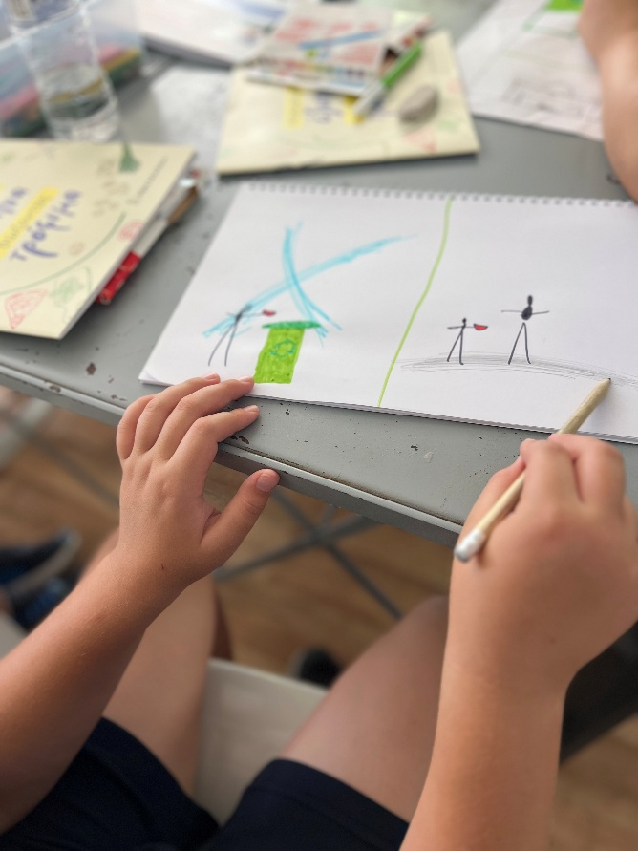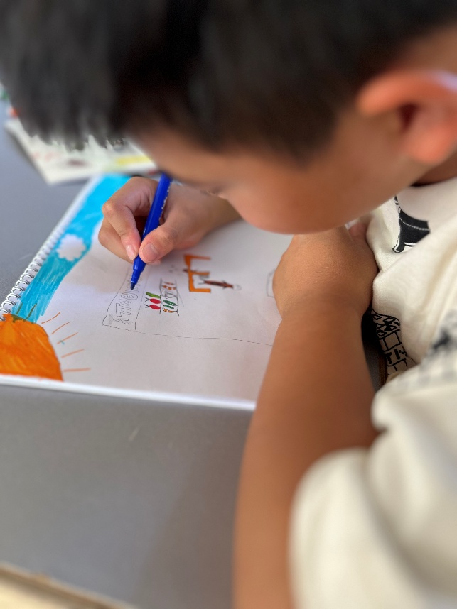
Image 14: Free-drawing session Image 15: Work in progress
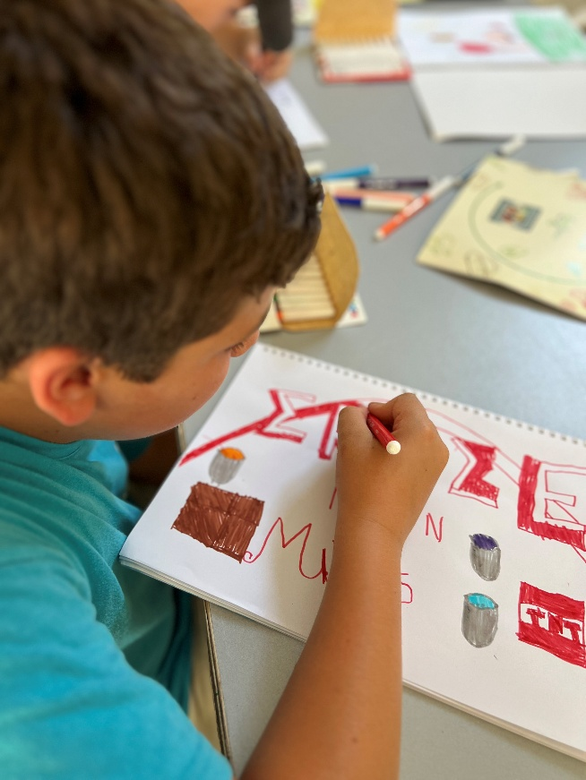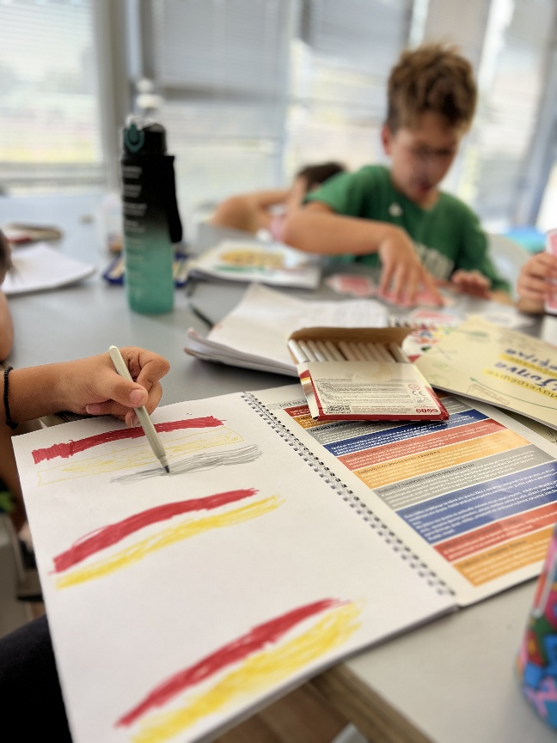
Image 16: Individual work Image 17: Sharing the table and materials

2.3.3 Presentation and Interpretation of Paintings
The paintings produced display a wide range of expressions and themes, reflecting the diversity of the children’s ideas. Although no specific theme was set, many works were indirectly linked to values such as cooperation, solidarity, and the avoidance of waste. Overall, the collection illustrates children’s creativity and confirms the role of art as an effective tool for awareness-raising. Representative photographs of the works follow.

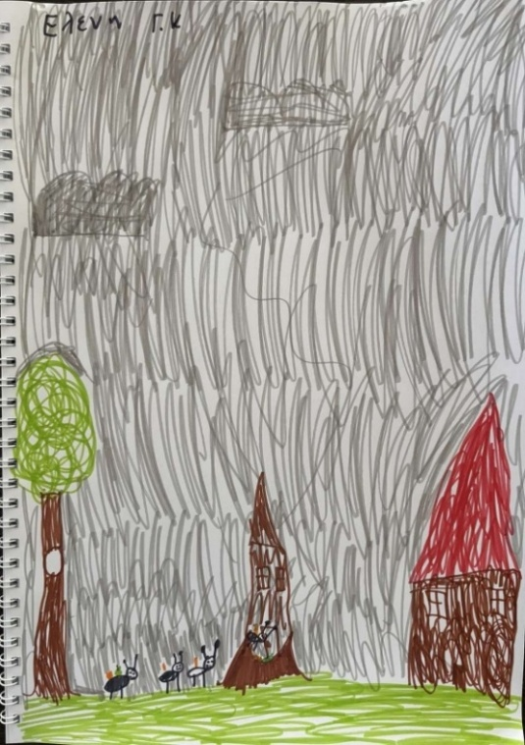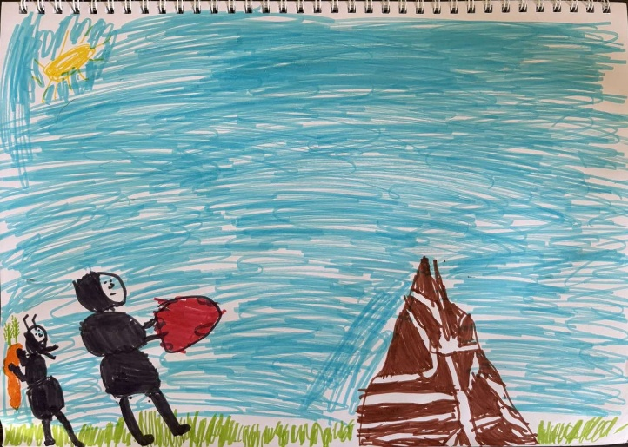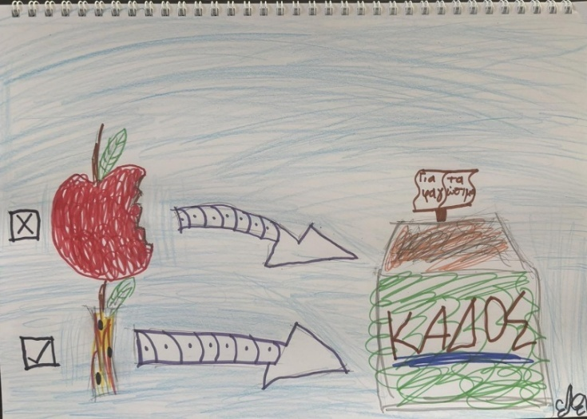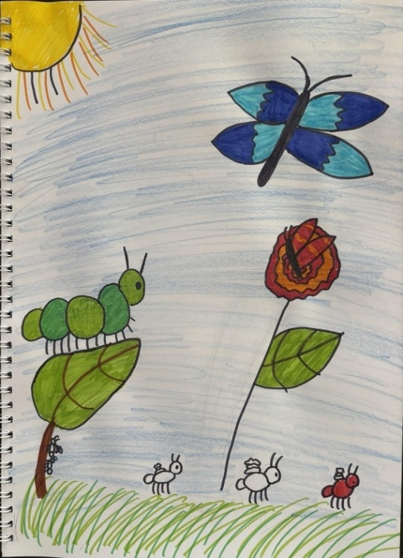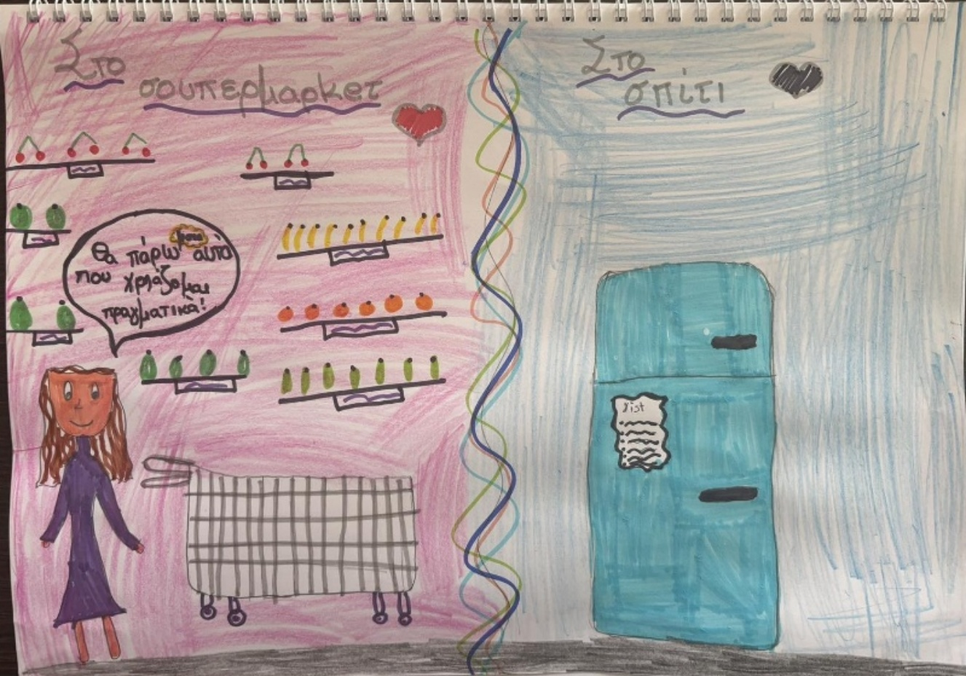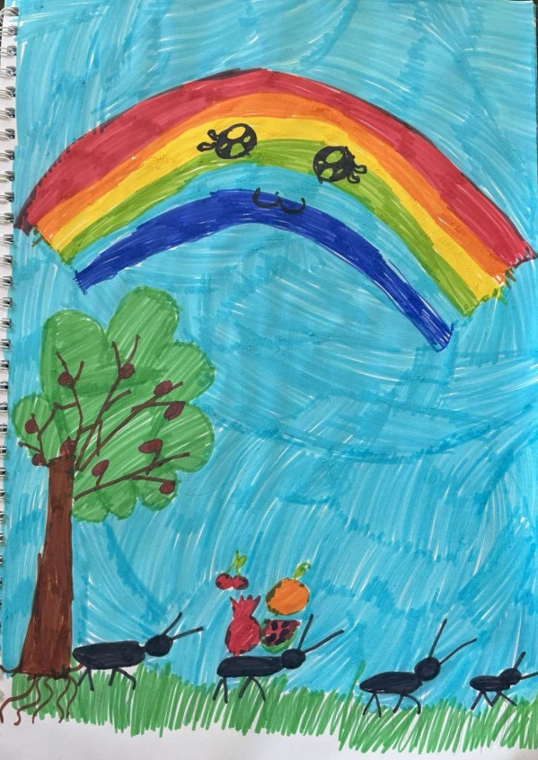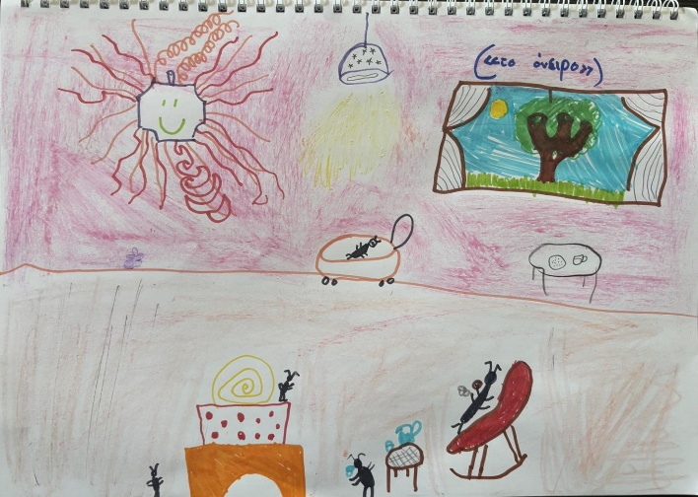
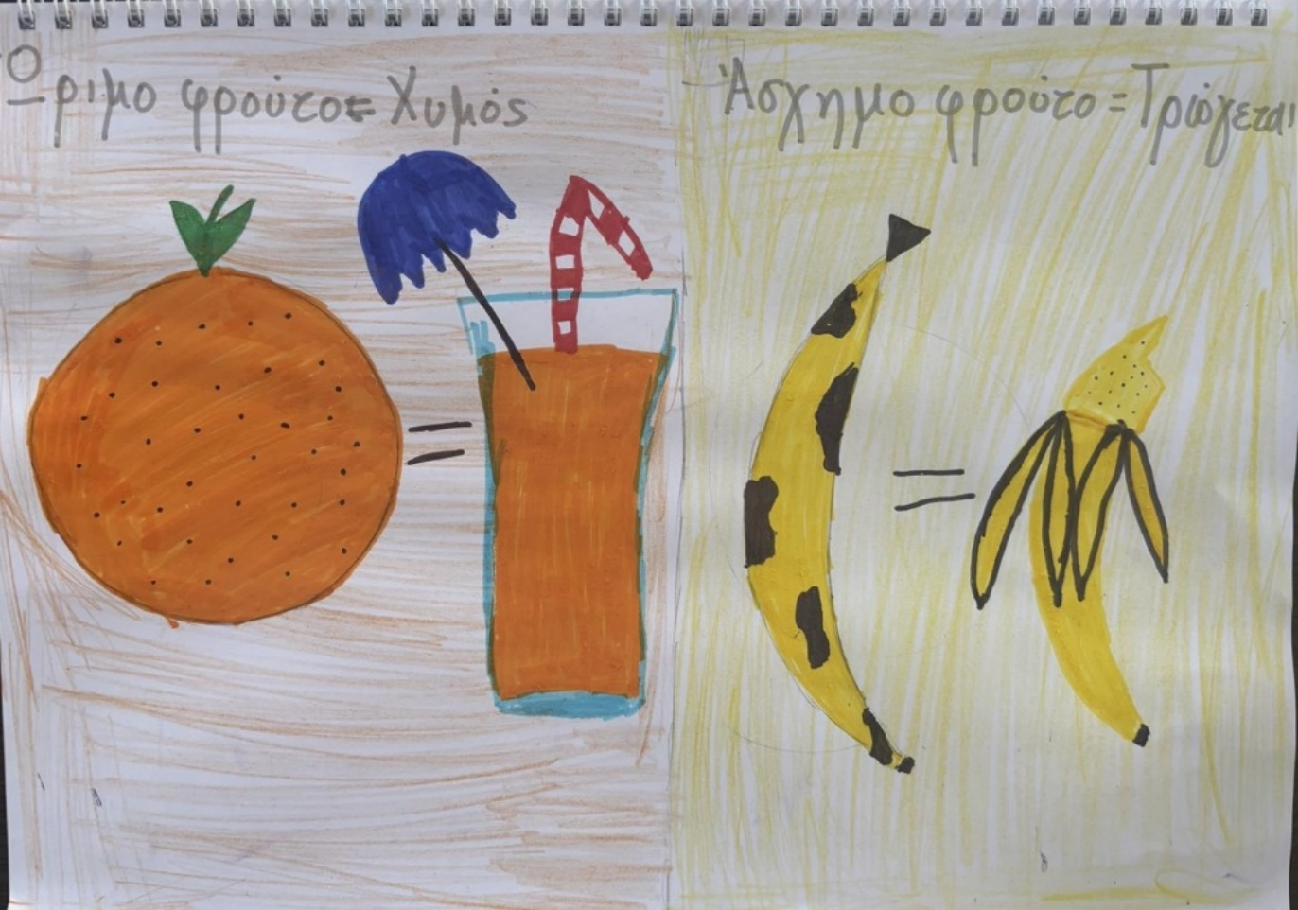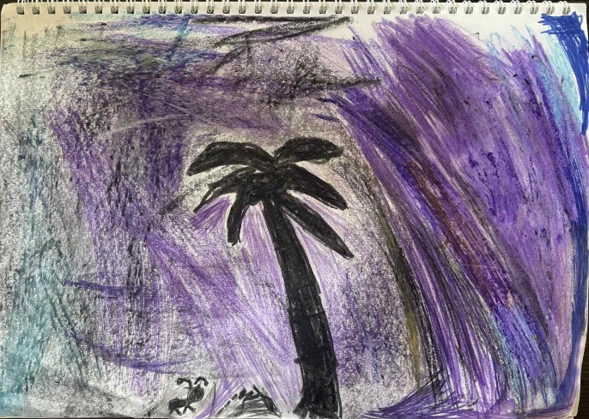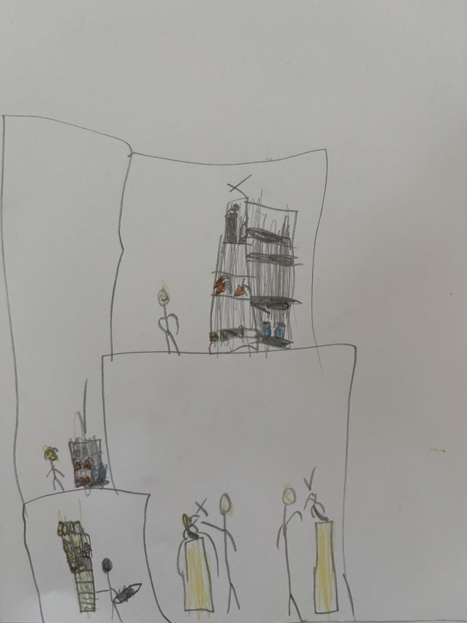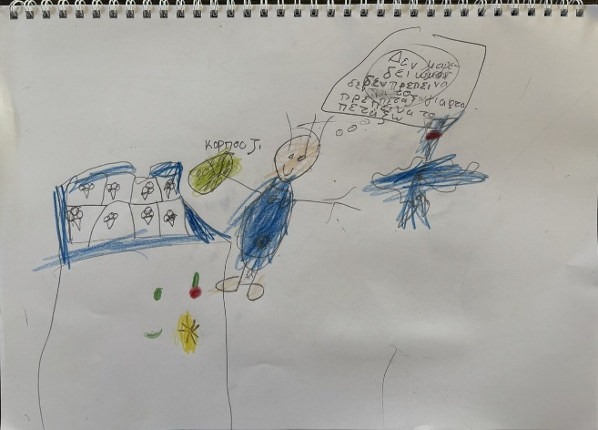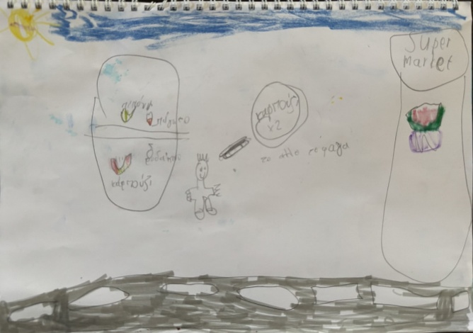
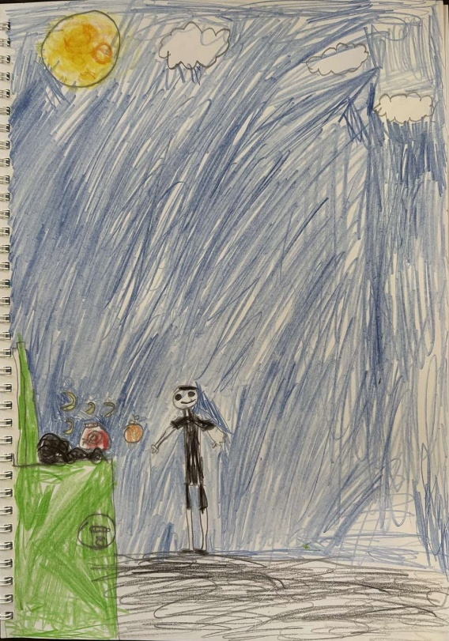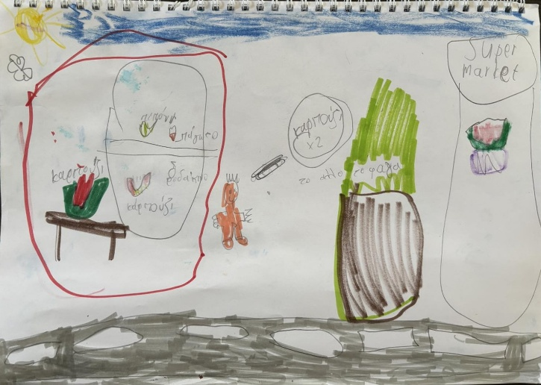
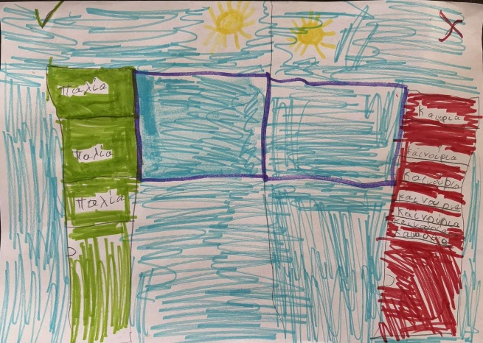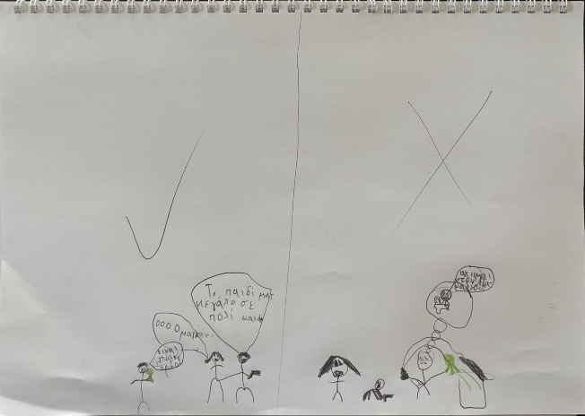
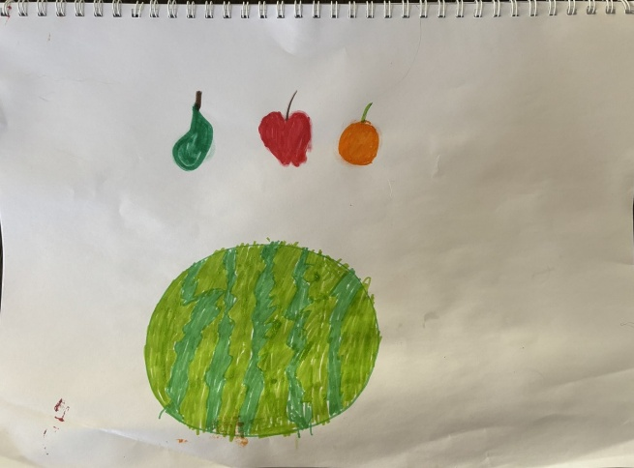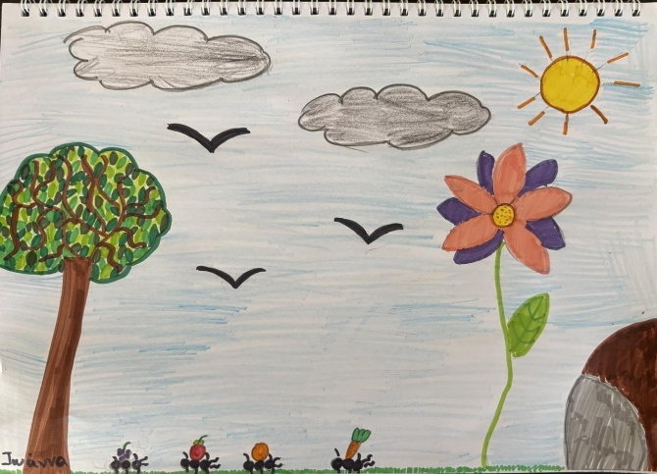
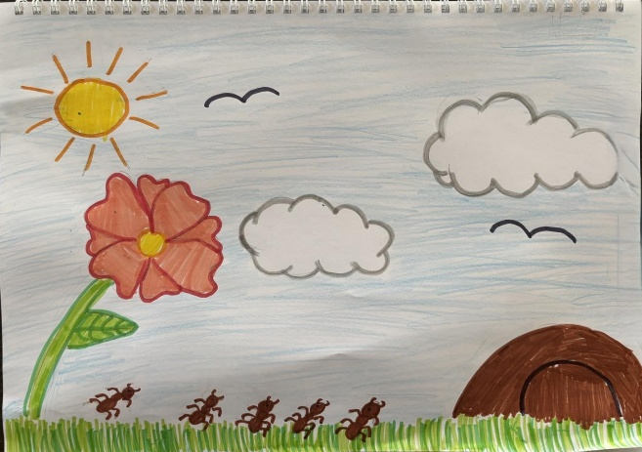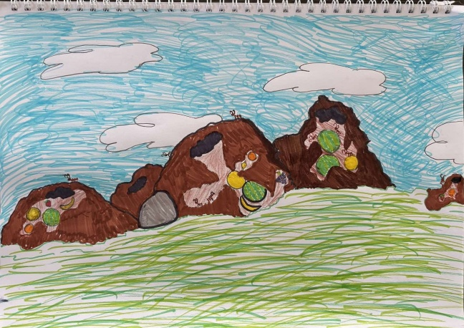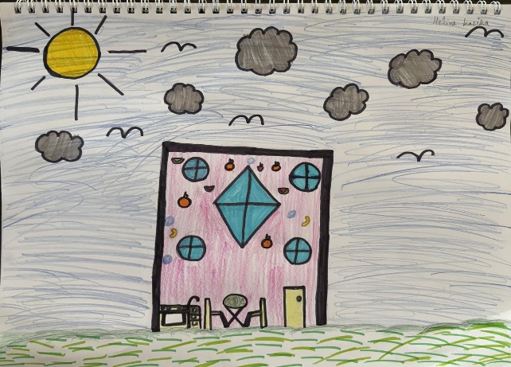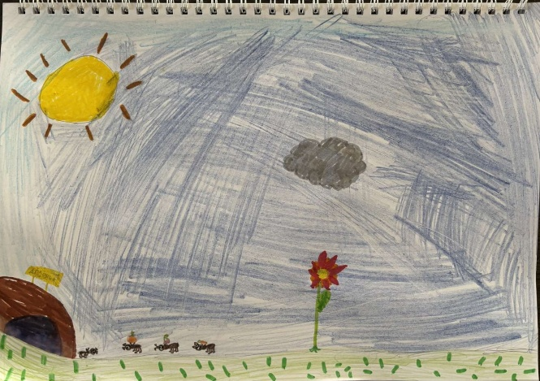
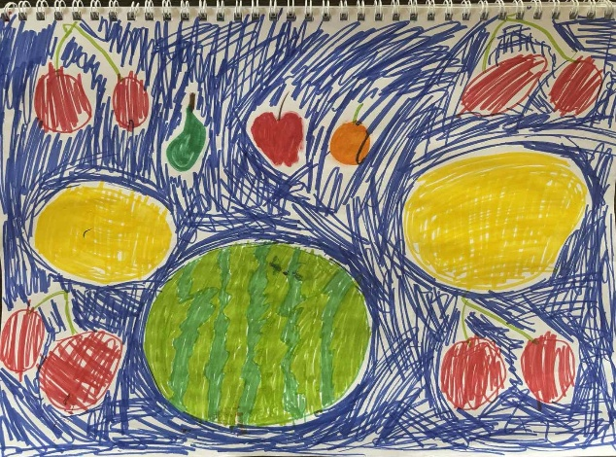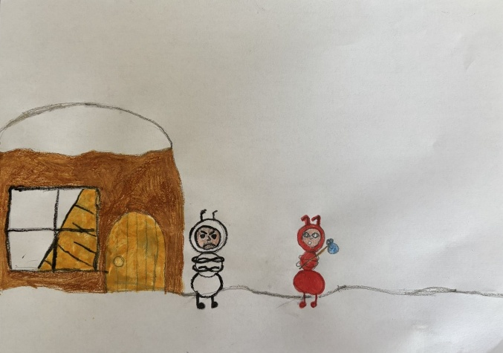
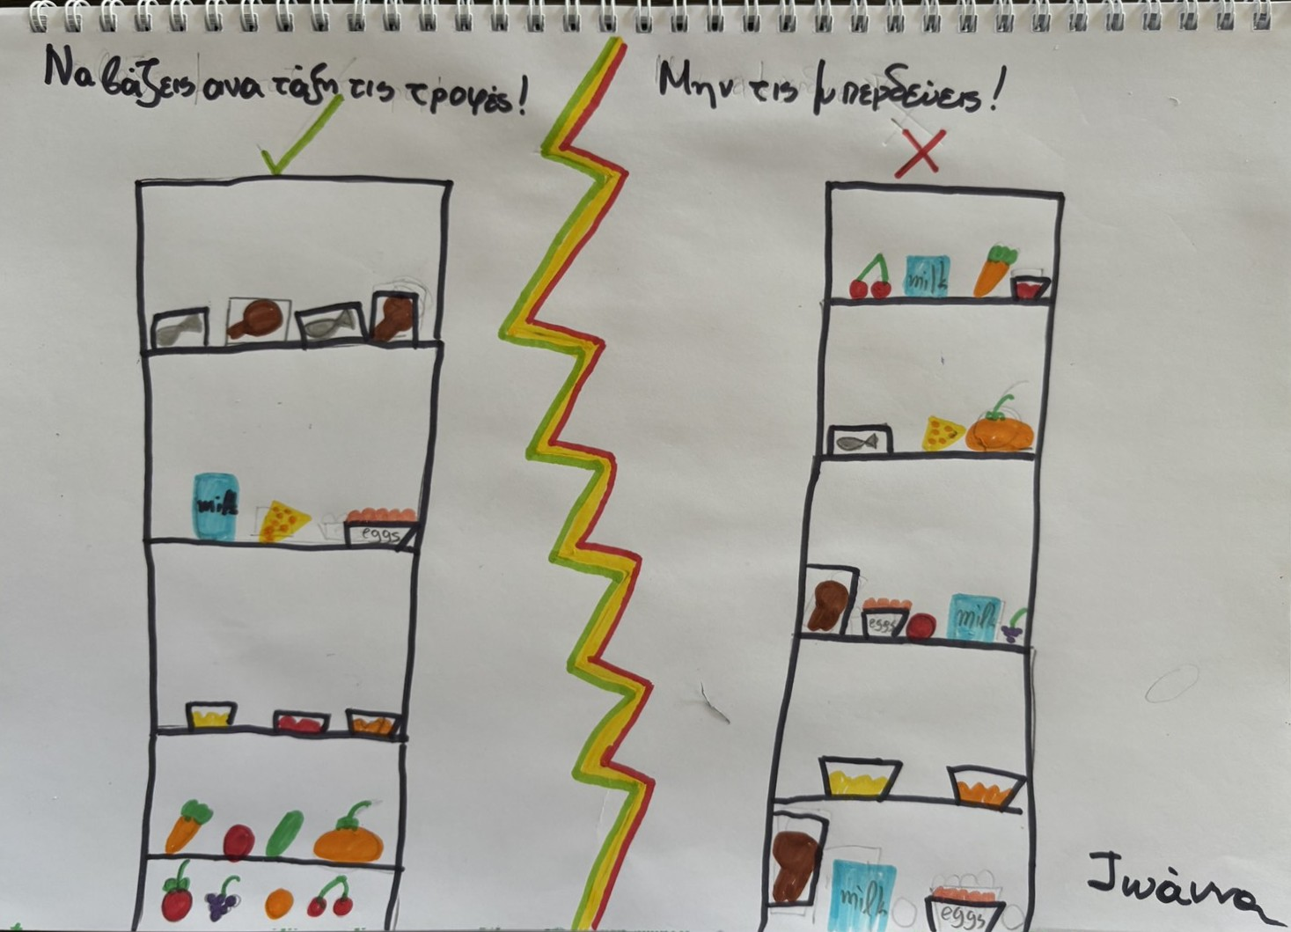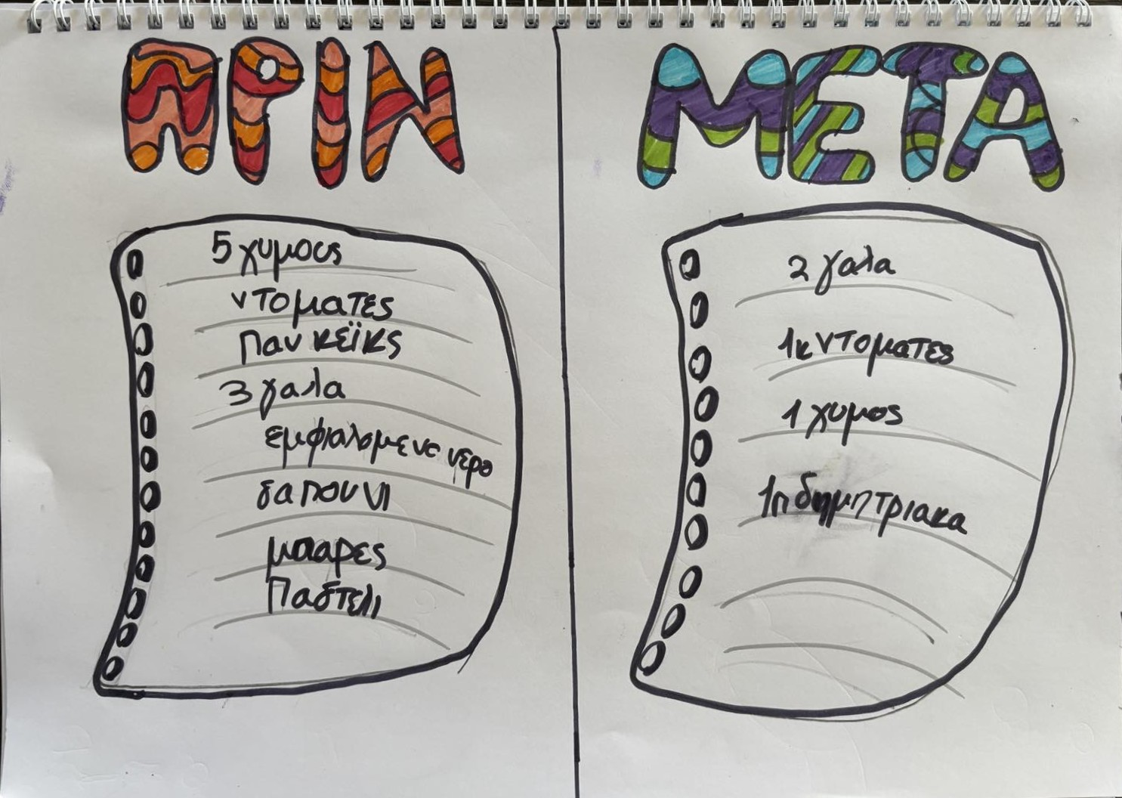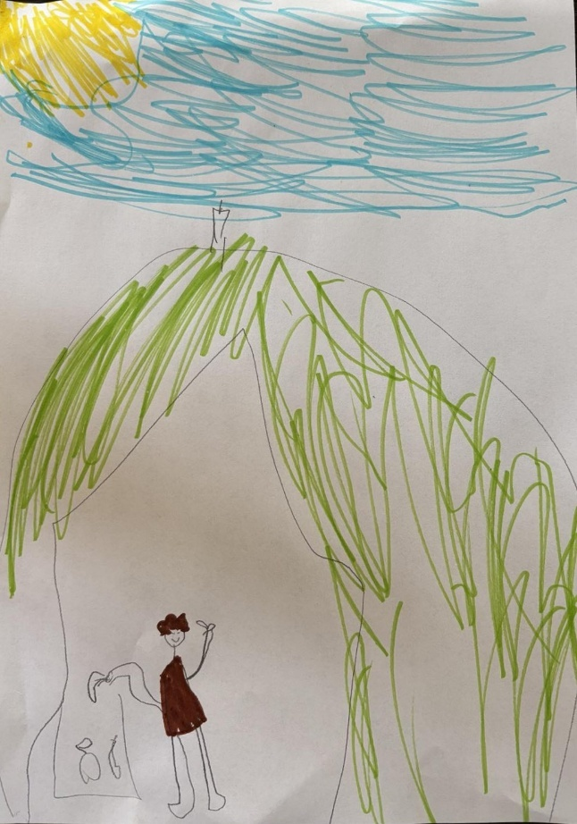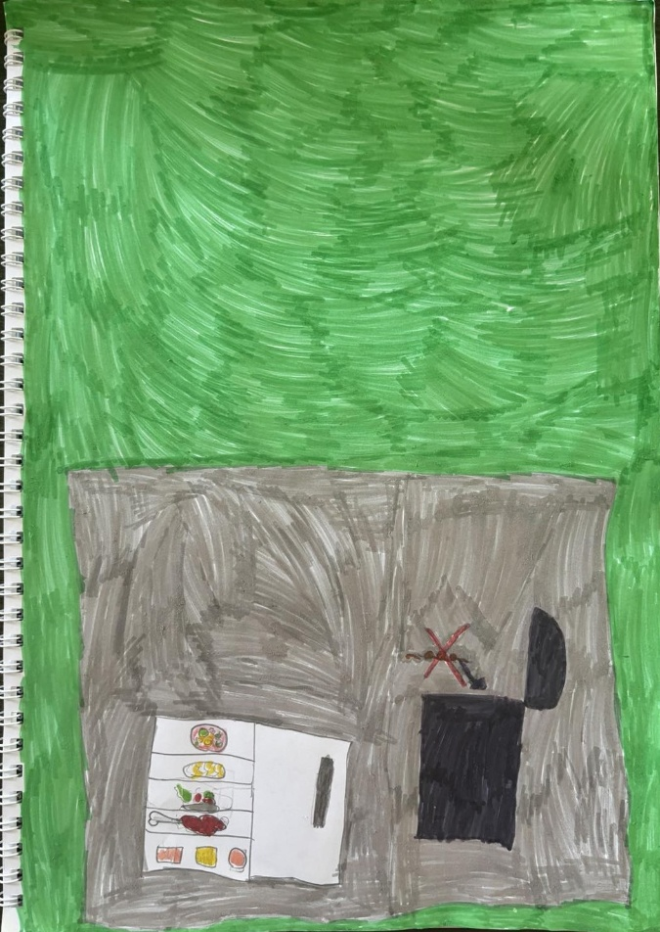

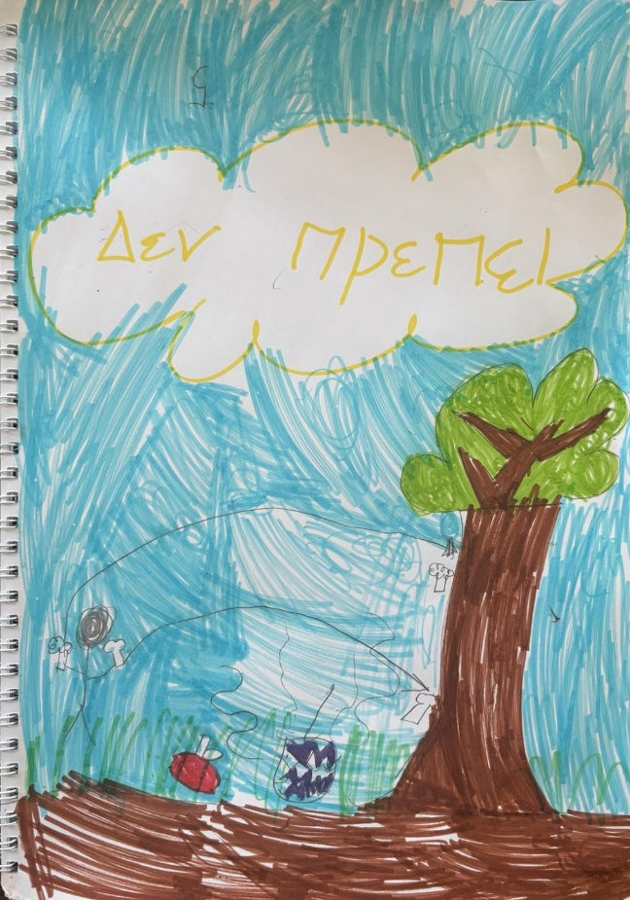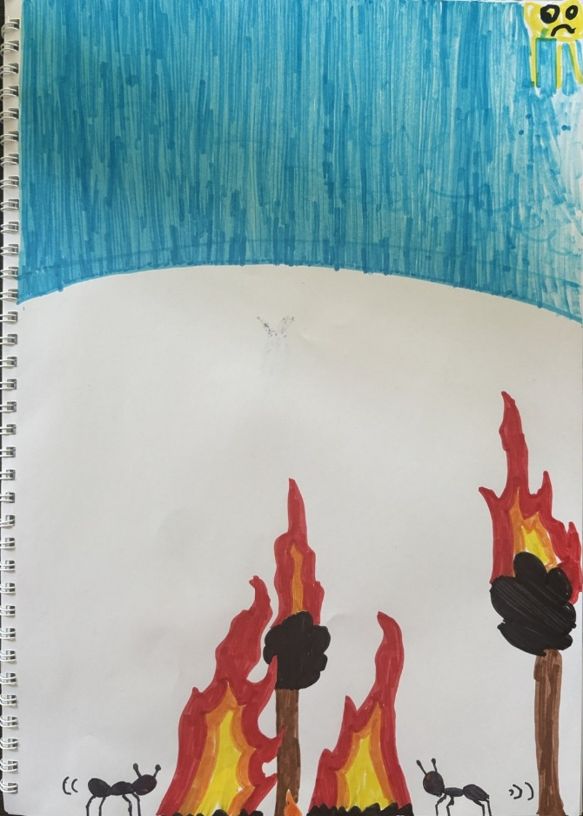
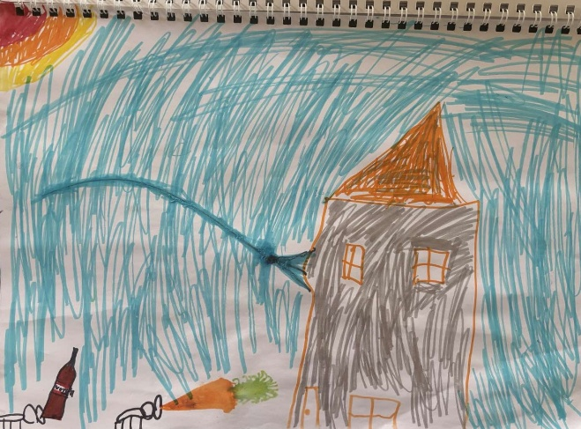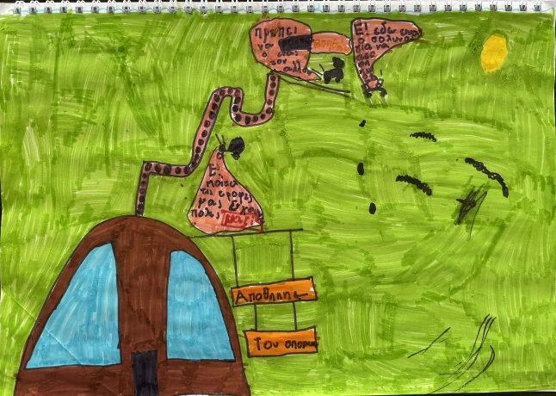

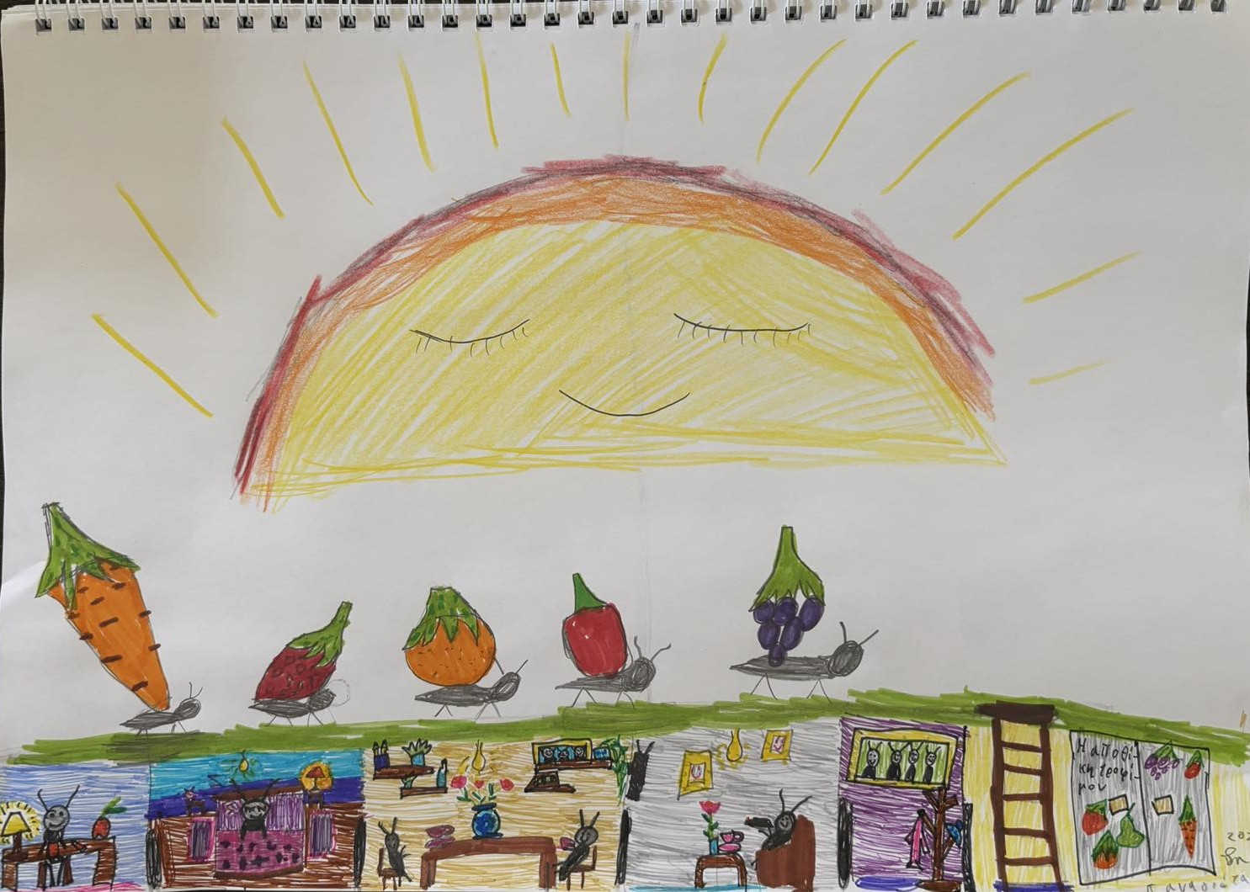

3. Conclusions
The implementation of the three educational activities within the framework of the Sports Camp highlighted the effectiveness of using various methods to enhance children's awareness of food waste prevention and sustainable waste management. The storytelling provided an attractive narrative framework that facilitated the emotional assimilation of values ​​such as solidarity, fairness and waste prevention. The waste counting activity, on the other hand, offered a tangible and practical experience, allowing children to directly observe the results of their behavior regarding waste disposal and to understand the importance of proper sorting. Finally, the free painting activity created a space of liberated creativity, through which the children were able to express the concepts of the value of food, cooperation and environmental responsibility.

Overall, the combination of these actions demonstrates that a multidimensional approach, combining structured learning, practical application and creative expression, can maximize learning outcomes. The program suceeded to strengthen sustainable attitudes and encourage long-term behavioral change. These results confirm the potential of experiential, participatory and artistic methodologies as effective tools for environmental education for young children.

